**VISVESVARAYA TECHNOLOGICAL UNIVERSITY**

**“JnanaSangama”, Belgaum -590014, Karnataka.**



**LAB REPORT**

**on**

**Object Oriented Analysis and Design**

***Submitted by***

**Harish Singh Mehra(1BM19CS222)**

***in partial fulfillment for the award of the degree of***

**BACHELOR OF ENGINEERING**

***in***

**COMPUTER SCIENCE AND ENGINEERING**



**B.M.S. COLLEGE OF ENGINEERING**

**(Autonomous Institution under VTU)**

**BENGALURU-560019**

**April-2022 to July-2022**

1

**B. M. S. College of Engineering,**

**Bull Temple Road, Bangalore 560019**

(Affiliated To Visvesvaraya Technological University, Belgaum)

**Department of Computer Science and Engineering**



**CERTIFICATE**

This is to certify that the Lab work entitled “Object Oriented Analysis And Design Lab” carried out by **Harish Singh Mehra(1BM19CS222),** who is bonafide student of **B. M. S. College of Engineering.** It is in partial fulfillment for the award of **Bachelor of Engineering in Computer Science and Engineering** of the Visvesvaraya Technological University, Belgaum during the academicyear 2021-2022. The Lab report has been approved as it satisfies the academic requirements in respect of a **Object Oriented Modelling and Design- (20CS6PCOMD**) work prescribed for the said degree.

Latha N R

**Dr. Jyothi S Nayak**

Assistant Professor

Department of CSE

Professor and Head

Department of CSE

BMSCE, Bengaluru

BMSCE, Bengaluru

2

**Sl.**

**No.**

**1**

**2**

**3**

**4**

**5**

**6**

**7**

**Index Sheet**

|  |  |
| --- | --- |
| **Experiment Title** | **Page No.** |
| **College Information System** | **4** |
| **Hostel Management System** | **9** |
| **Stock Maintenance System** | **15** |
| **Coffee vending Machine** | **20** |
| **Online Shopping System** | **27** |
| **Railway Reservation System** | **32** |
| **Graphics Editor** | **37** |
|  |  |

**Course Outcome**

**CO4**

**Ability to conduct practical experiment to solve a given problem using Unified Modeling language.**

3

**1. College Information System**

**Problem statement:**

Design UML diagrams for College Information System with system requirements specification.

**Software Requirements Specification (SRS):**

A centralized approach and system for managing, storing, accessing and updating all the information and details present in relevance to students, and teaching and non-teaching faculty, increasing efficiency and convenience of information management in educational institutions.

* Educational institutions should be able to add, edit and view student personal details, like name, age, gender, email, phone number, address and so on.
* Educational institutions should be able to add, edit and view student academic details, like USN, department, semester and registered courses.
* Faculty should be able to view all student personal details, and should be able to view and edit internal evaluation marks and attendance of students.
* The COE office should be able to view all student details, and view and edit internal and examination marks, and publish results.
* Placement section should be able to view all student details, and add companies coming to the campus for placements.
* Management section should be able to view, add and edit teaching and non-teaching staff details.
* Students should not be allowed to edit their personal or academic details.
* The system should be convenient and easy to use by students, management and faculty.
* The system should be a reliable source of information viewing (most importantly, academic grades) for students, COE and faculty.

4

**Class Diagram:**

The below shown class diagram contains the following classes: Admin, Department, Staff, Course, Teaching, Non-Teaching, Placement, COE, Student, Hostel, Facility, Library with multiplicities as shown.

Association: Admin handles Department, Placement and COE, Student gets Facility, Coursesare chosen by student.

Generalization: Hostel, library are generalized to Facility class.

Aggregation: Staff consists (aggregate of) Teaching and Non-Teaching.

Composition: Department has (or is composed of) Course and Saff.

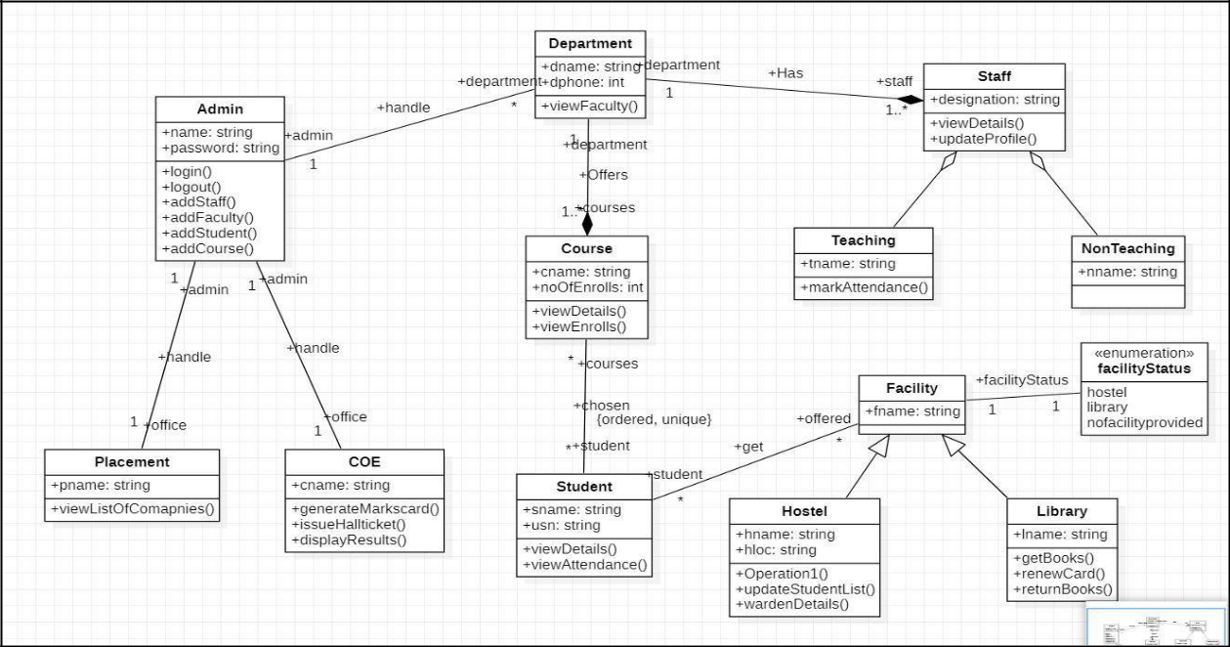

**State Diagram:**

**1. Advance state diagram**

The advanced state diagram depicted below contains one nested state and one submachine, which

on successful login shows the course details and profileView procedure of student. It contains

initial state and termination state with Courses as a nested state including the required simple states.

It also has a submachine state named ProfileView with initial, termination state along with simple

states; Display profile, Edit, Save.

5

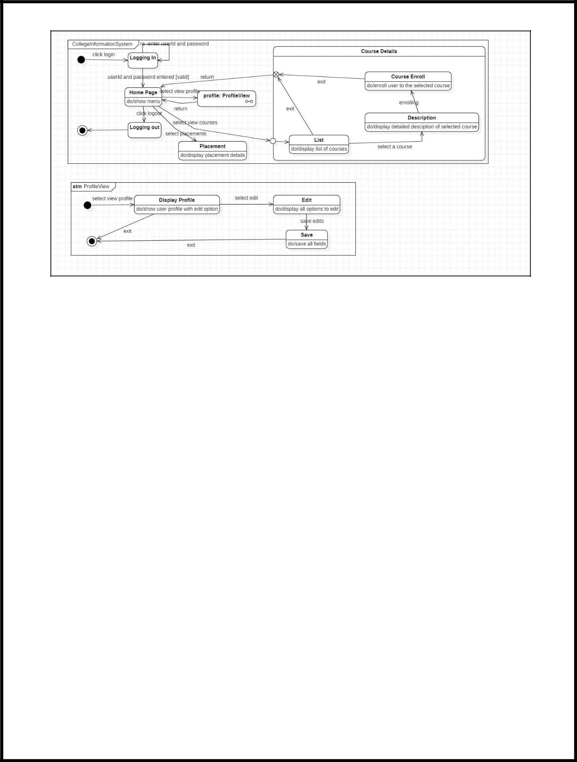

**Use Case Diagram:**

**1. Advance use case diagram**

The advanced use case diagram has extra functionalities which includes extends, includes and generalization. The show available books use case extends view books use case, view events use case includes add events and remove events, issue books use case includes verify student and check availability of book.

6

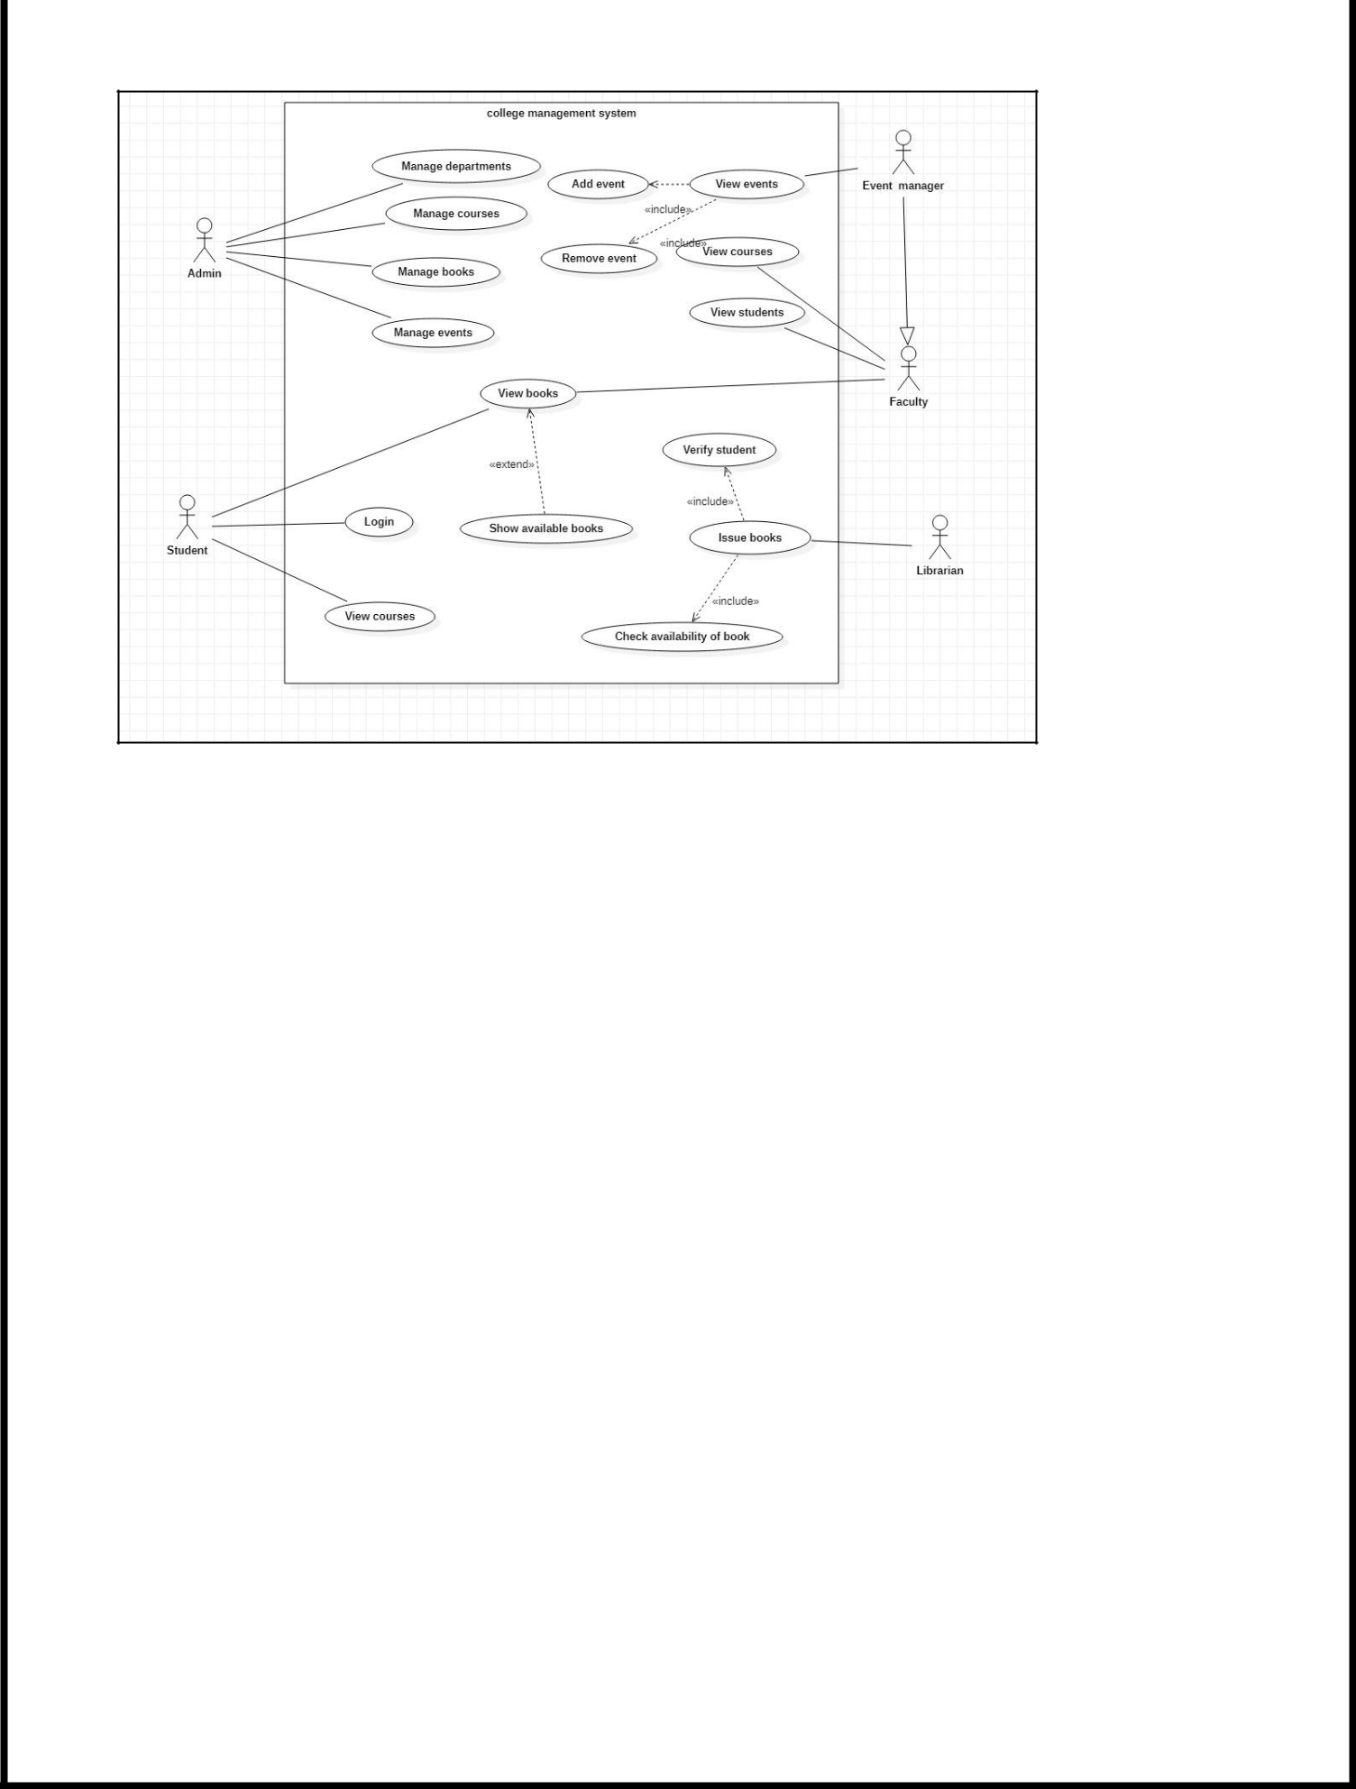

**Sequence Diagram:**

**1. Advance sequence diagram**

The lifeline is the dotted line and the rectangles represent the period of time the object is executing and is hence called activation.

The recursive function of verify is shown by double activation rectangle of verify payment and successful message.

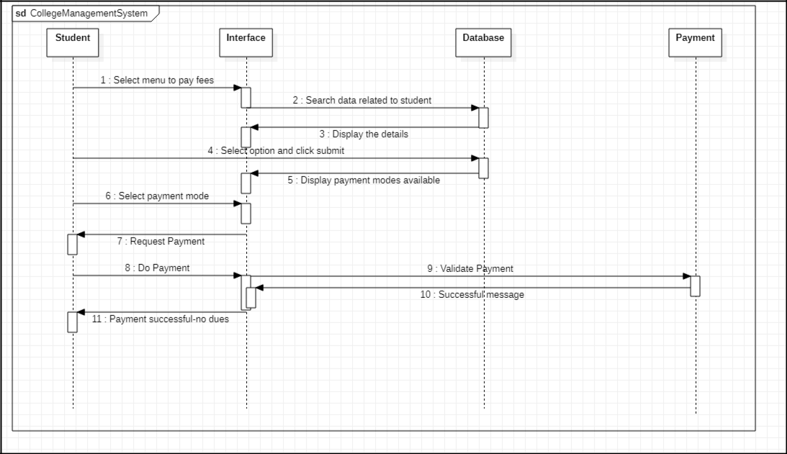

7

**Activity Diagram:**

**1. Advance activity diagram:**

The advanced activity diagram starts from initiation and then user login activity where a signal is sent to the network for request validation and upon confirmation the control flows to profile and then fee payment activity. There are three swimlanes for Payment gateway, Database manager and accountant where validate payment, update database and generate receipt respectively. Then the control flows to the home page and then termination activities.

8

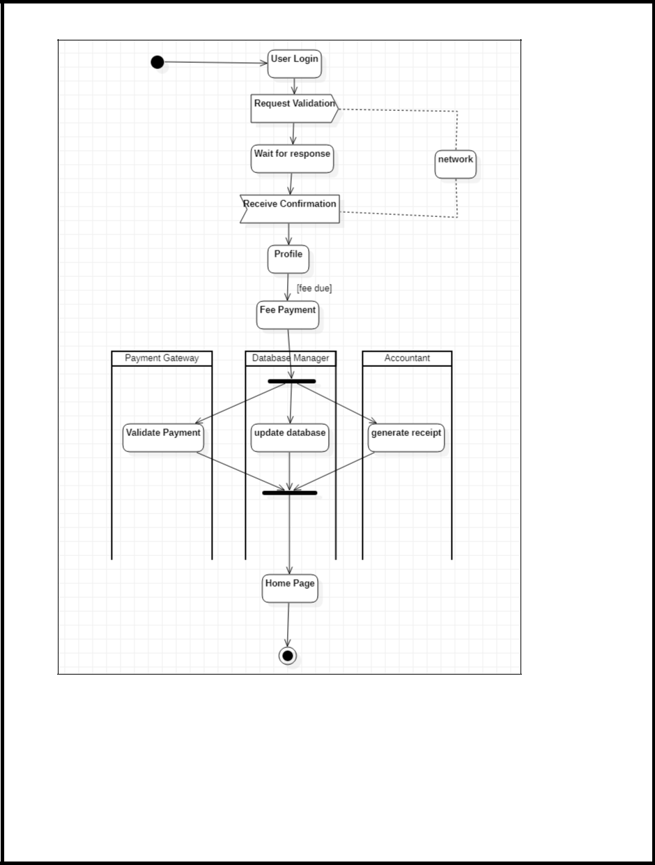

9

**2. Hostel Management System**

**Problem statement:**

Design UML diagrams for Hostel Management System with system requirements specification.

**Software Requirements Specification (SRS):**

The purpose of the Hostel Management System is to carry out different operations of a hostel. This system will provide ease of use to the staff of the hostel by performing all work on computers. It helps to manage student and staff records.

* Admin can login using credentials provided to him.
* Admin can allot room to students.
* Students can login using the credential provided and can give feedback about staff.
* Admin can review the feedback provided by students.
* Admin can appoint staff.
* Students can provide message feedback.
* Mess managers can review the mess feedback.
* Mess manager can update the menu list.
* Admin can assign work to staff members.
* The system should be easy to handle.
* System should give expected performance results.
* The response time should be small.

10

**Class Diagram:**

The below shown class diagram contains the following classes: Person, Student, Administrator, Warden, Hostel, Rooms_allocation, Receipt_generation, Rooms, Bed with multiplicities as shown. Association: Warden manages Student, Student stays_in Hostel, Student is allocated to Room_allocation, Administrator decides_room Room_allocation, Administrator generates Receipt_generation, .

Generalization: Student, Administrator and Warden are generalized to Person class.

Aggregation: Rooms class (composed of) with Bed class.

Composition: Hostel has (or is composed of) Rooms.

Enumeration: RoomType.

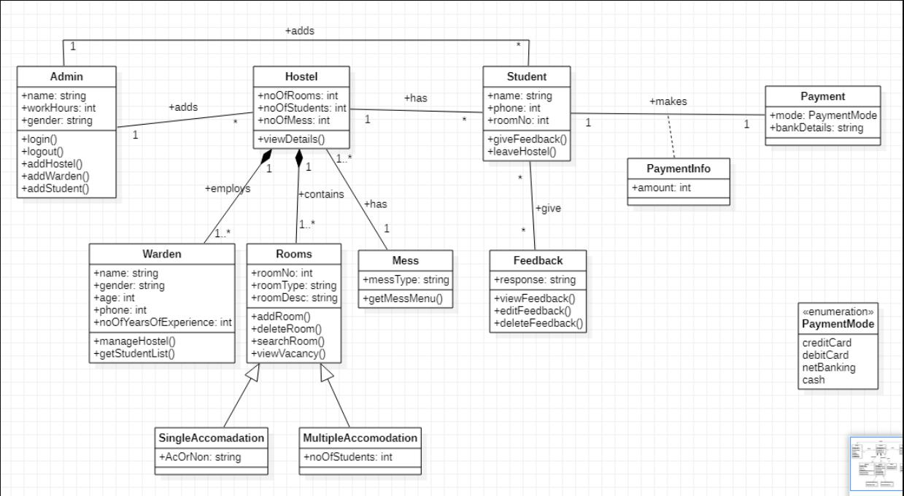

11

**State Diagram:**

**1. Advance state diagram**

The advanced state diagram depicted below contains one nested state and one submachine, which on successful login shows the mess details and room allocation procedure. It contains initial state and termination state with Mess as a nested state including the required simple states. It also has a submachine state named RoomAllocation with initial, termination state along with simple states; Blocks, Rooms, Allocate,Payment.

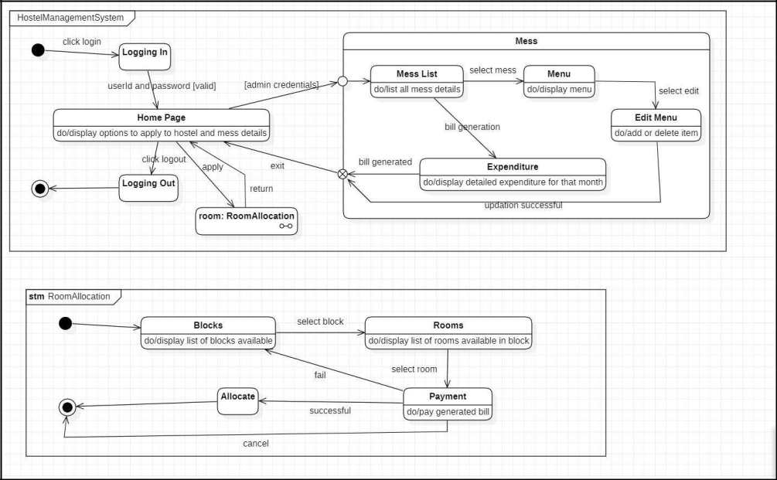

**Use Case Diagram:**

**1. Advance use case diagram**

The advanced use case diagram has extra functionalities which includes extends, includes and generalization. The edit hostel info use case extends add room use case, collect fee use case includes verify student, add room use case includes delete room use case.

12

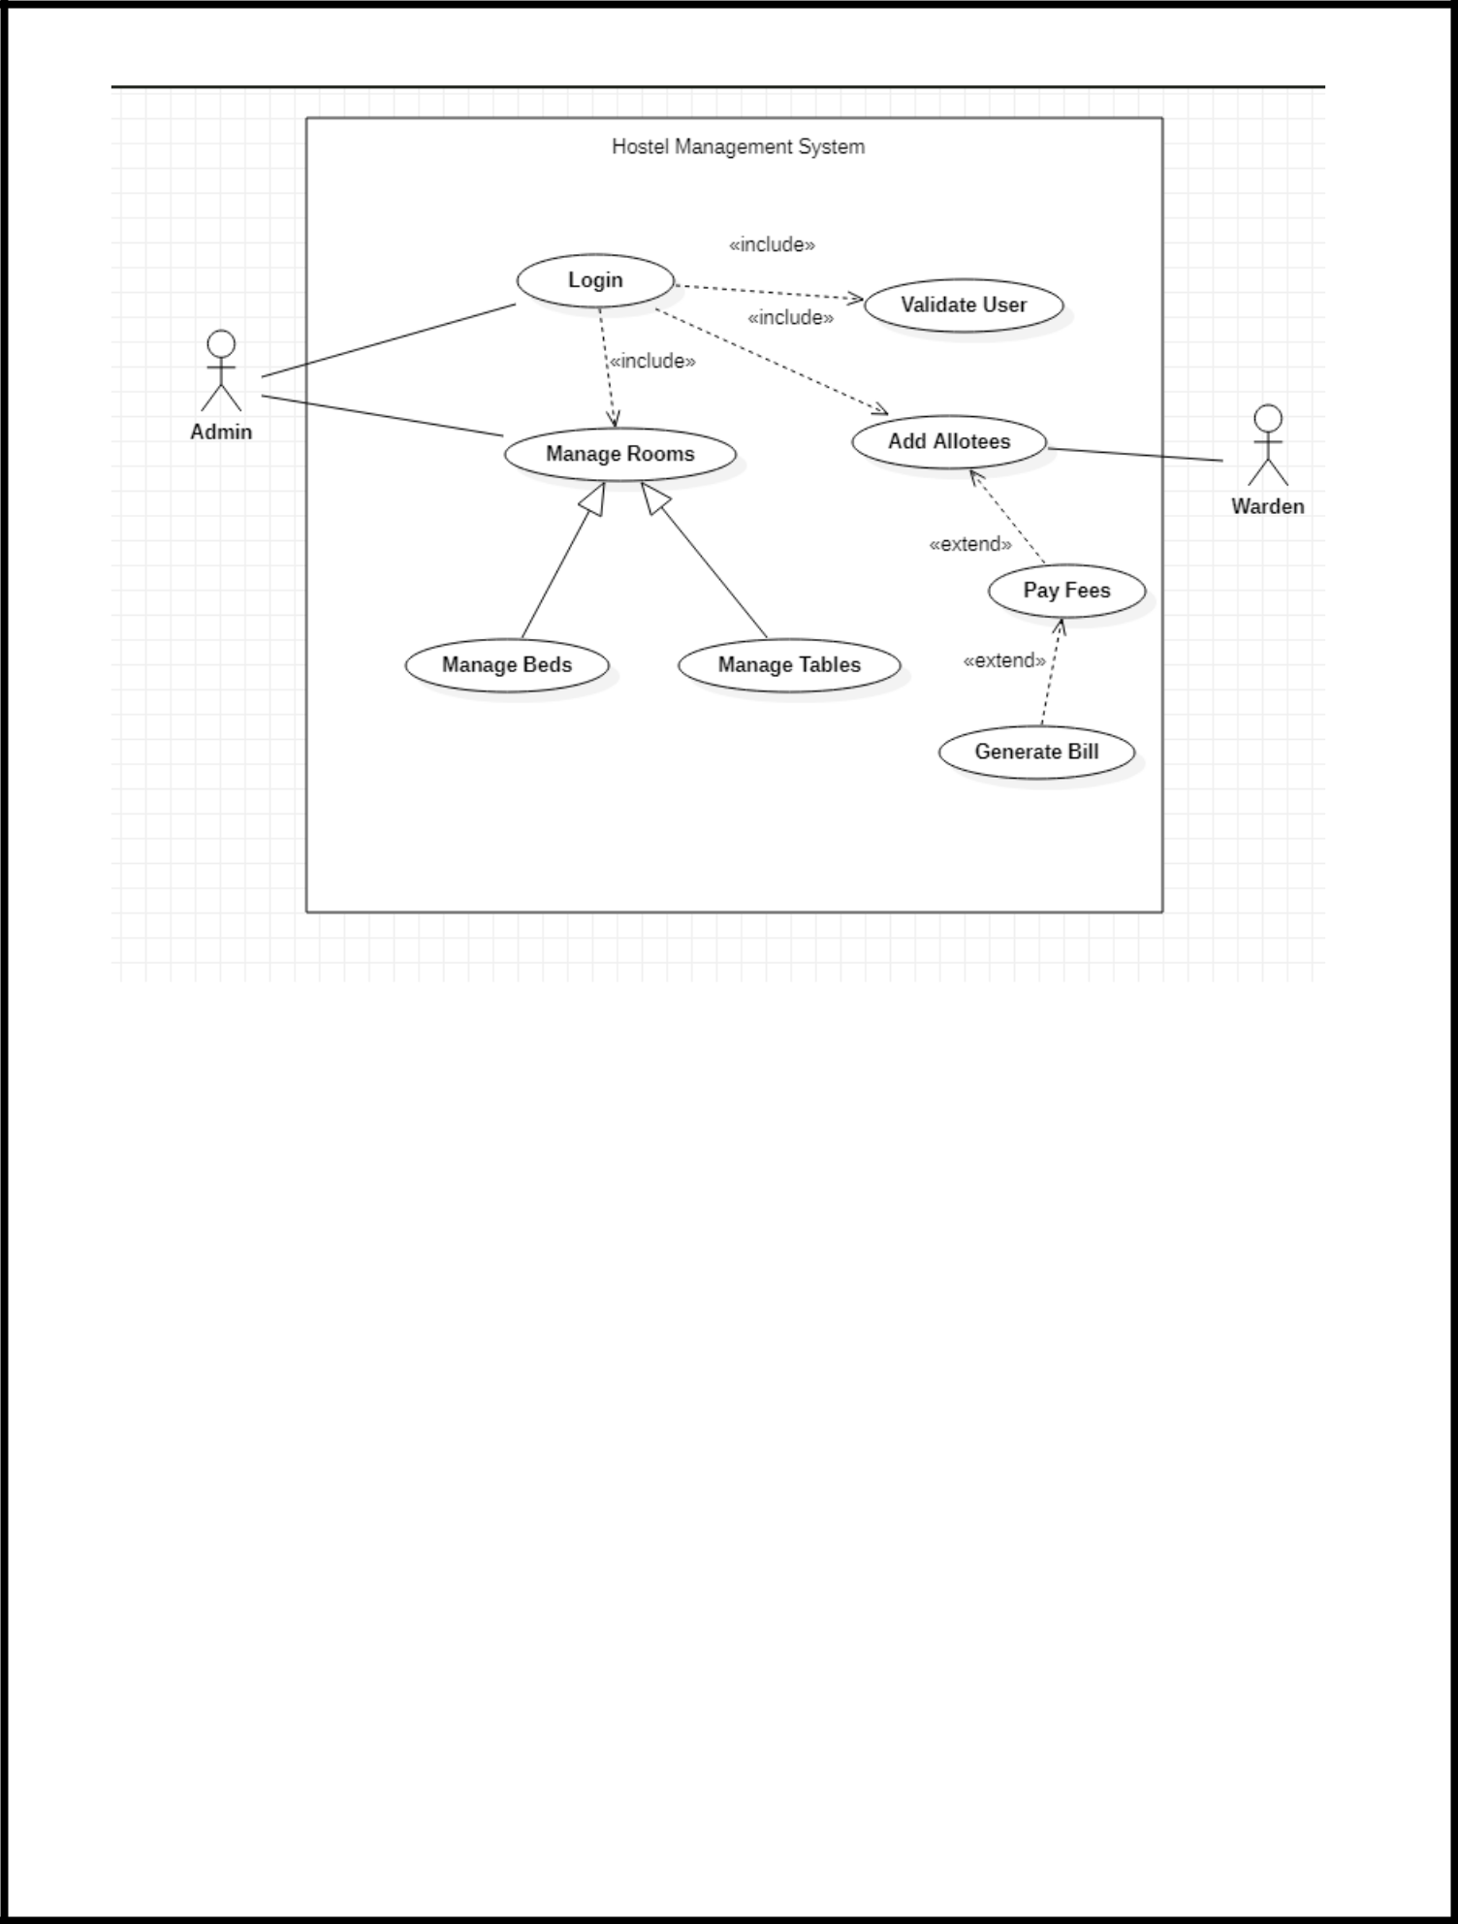

13

**Sequence Diagram:**

**1. Advance sequence diagram**

The lifeline is the dotted line and the rectangles represent the period of time the object is executing and is hence called activation.

The Login actor has self-message to check with the registration of the student.

Async and sync signal replies (dotted line) are used to reply back with specificity to the object.

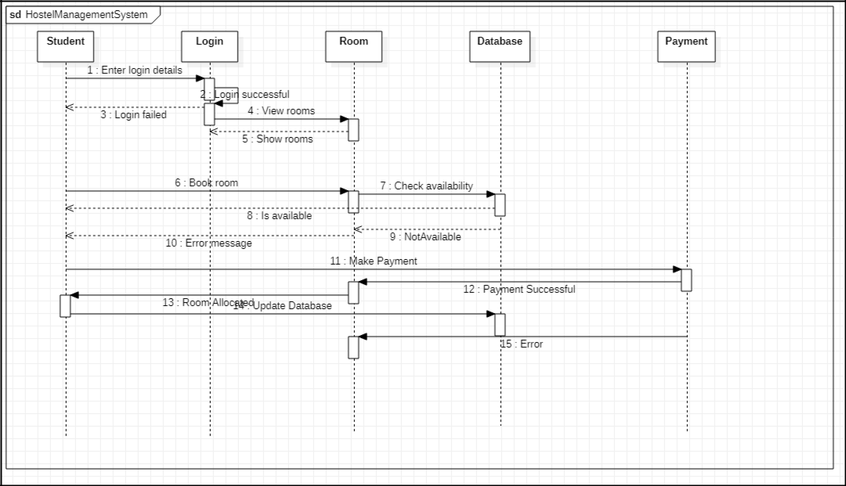

**Activity Diagram:**

**1. Advance activity diagram**

The advanced activity diagram starts from initiation and then in the student swimlane, student login activity where a signal is sent to the network for request validation and upon confirmation the control flows to profile and then book room activity. There are three swimlanes namely student, database, payment where validate student, update database and confiem payment respectively. Then the control flows to the home page and then termination activities.,

14

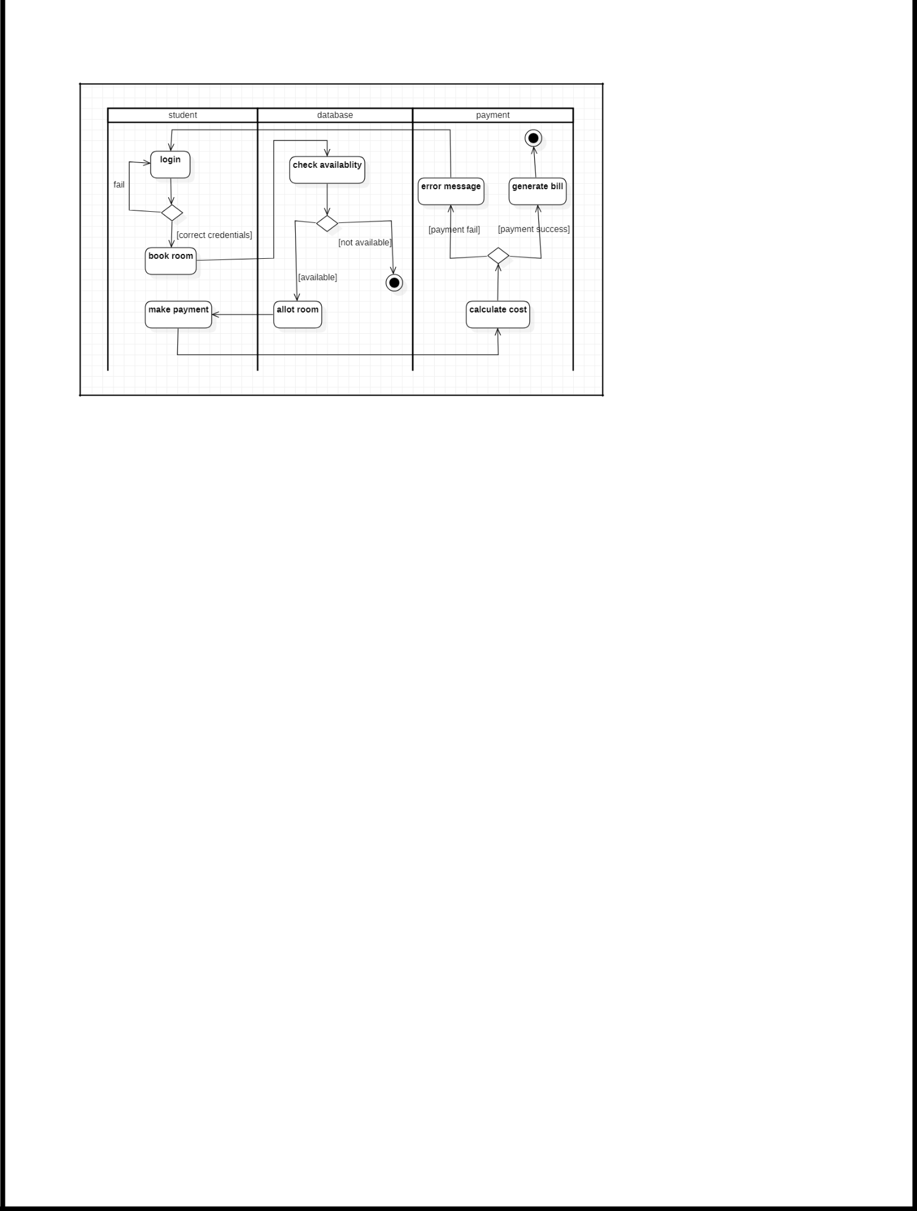

15

**3.Stock Maintenance System**

**Problem statement:**

Design UML diagrams for Stock Maintenance System provided with system requirements specification.

**Software Requirements Specification (SRS):**

The stock maintenance system will allow the employees to record information of the items

available in the store and generate reports based on the total amount of sales. The new system will

have a windows-based desktop interface to allow employees to enter the information of sales,

purchase orders, change employee preferences and create reports. The system retains information

on all the items in the shop. The system retains the records of the cost, expiry date, vendor details,

discount, quantity. The employee maintains the information of the sale of the item. He can add the

items at the right time and update the database. The customer can view the availability of the

required items and the price of the items. The customer can just view them but cannot make any

changes.

The process of the stock maintenance system is that the customer logs in to the particular site to

place the order for the customer product. The stock maintenance system is described sequentially

through steps

* The customer logs in to the particular site.
* They fill the customer details.
* They place the orders for their product.
* The vendor logs in and views the customer details and orders

**Class Diagram:**

The below shown class diagram contains the following classes: Role, Permisssion, Store, User, Stock, Product, Customer and Payment with multiplicities as shown.

Association: Customer buys Product, Customer buys Stocks, Customer pays Payment.

Generalization: User is generalized to Permission class and User is Generalized to Role. Aggregation: Stock class, Product class, Store class, Customer class are (composed of) with Permission class.

Composition: Payment needs (or is composed of) Permission and Stock (or is composed of) has Product.

16

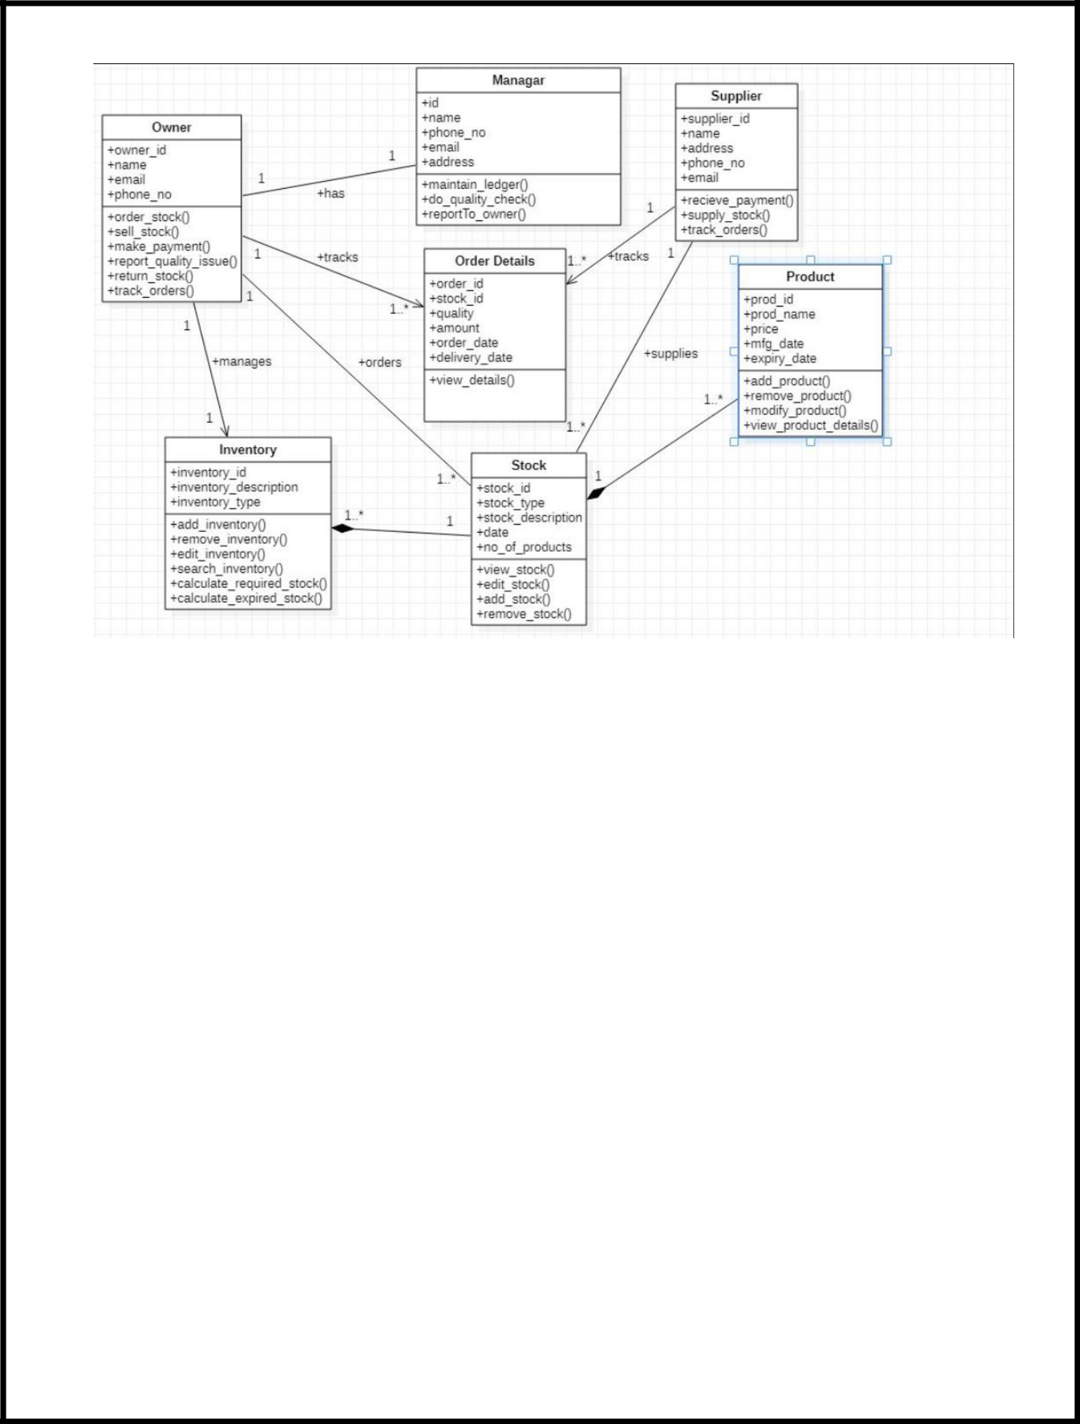

**State Diagram:**

**1. Advance state diagram**

The advanced state diagram depicted below contains one nested state and one submachine, which on successful login shows the StockStatus details and StockPurchase procedure. It contains initial state and termination state with Maintaining as a nested state including the required simple states. It also has a submachine state named StockPurchase with initial, termination state along with simple states; Inventory check, Sell, Payment, Validation.

17

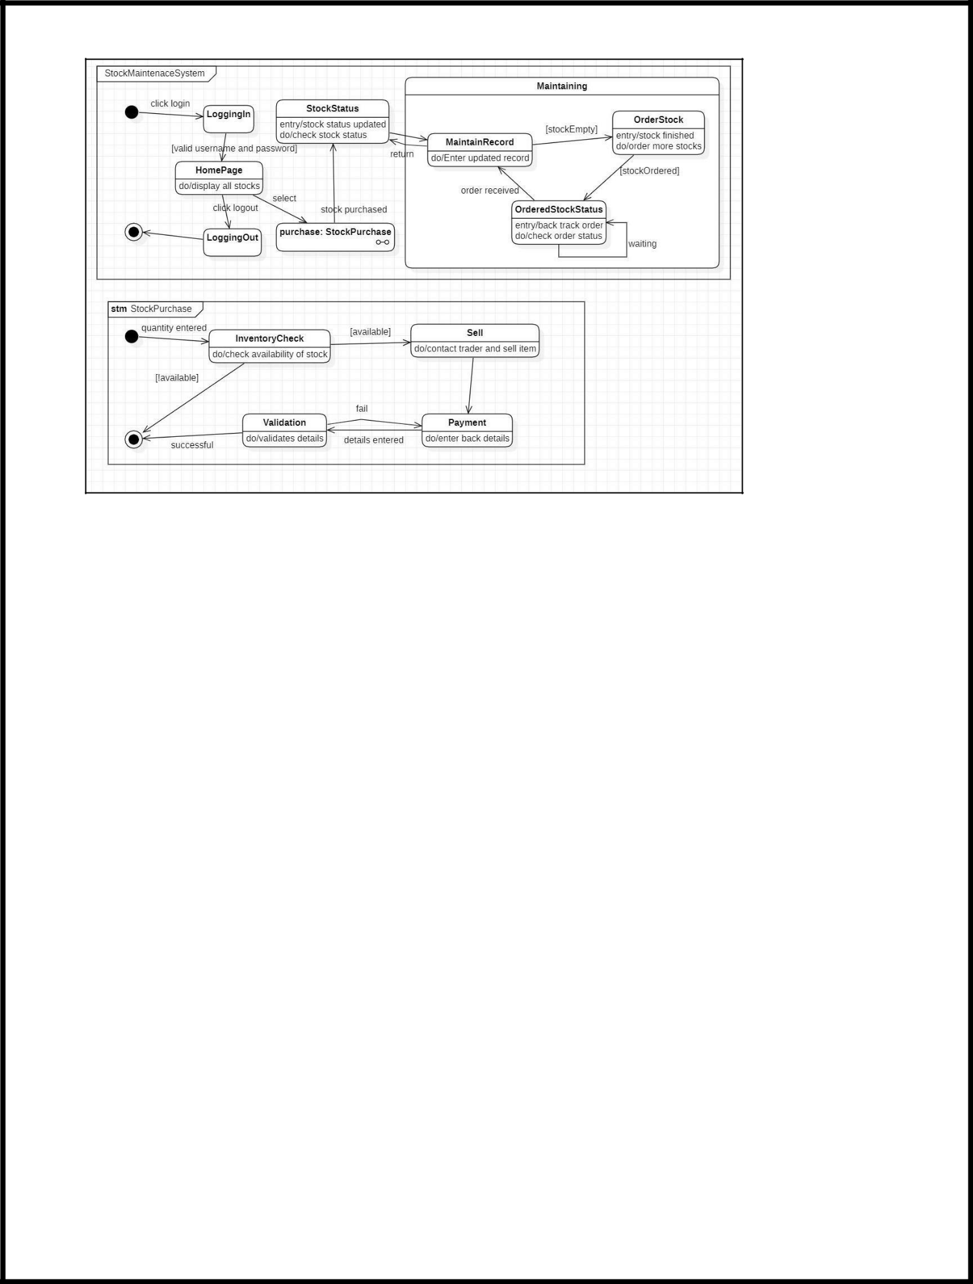

**Use Case Diagram:**

**1. Advance use case diagram**

The advanced use case diagram has extra functionalities which includes extends, includes and generalization. The stock level use case extends place order use case, detective shipment use case extends check quality criteria use case , shipment error use case extends receive shipment with bill use case, pay bill use case includes track order use case.

18

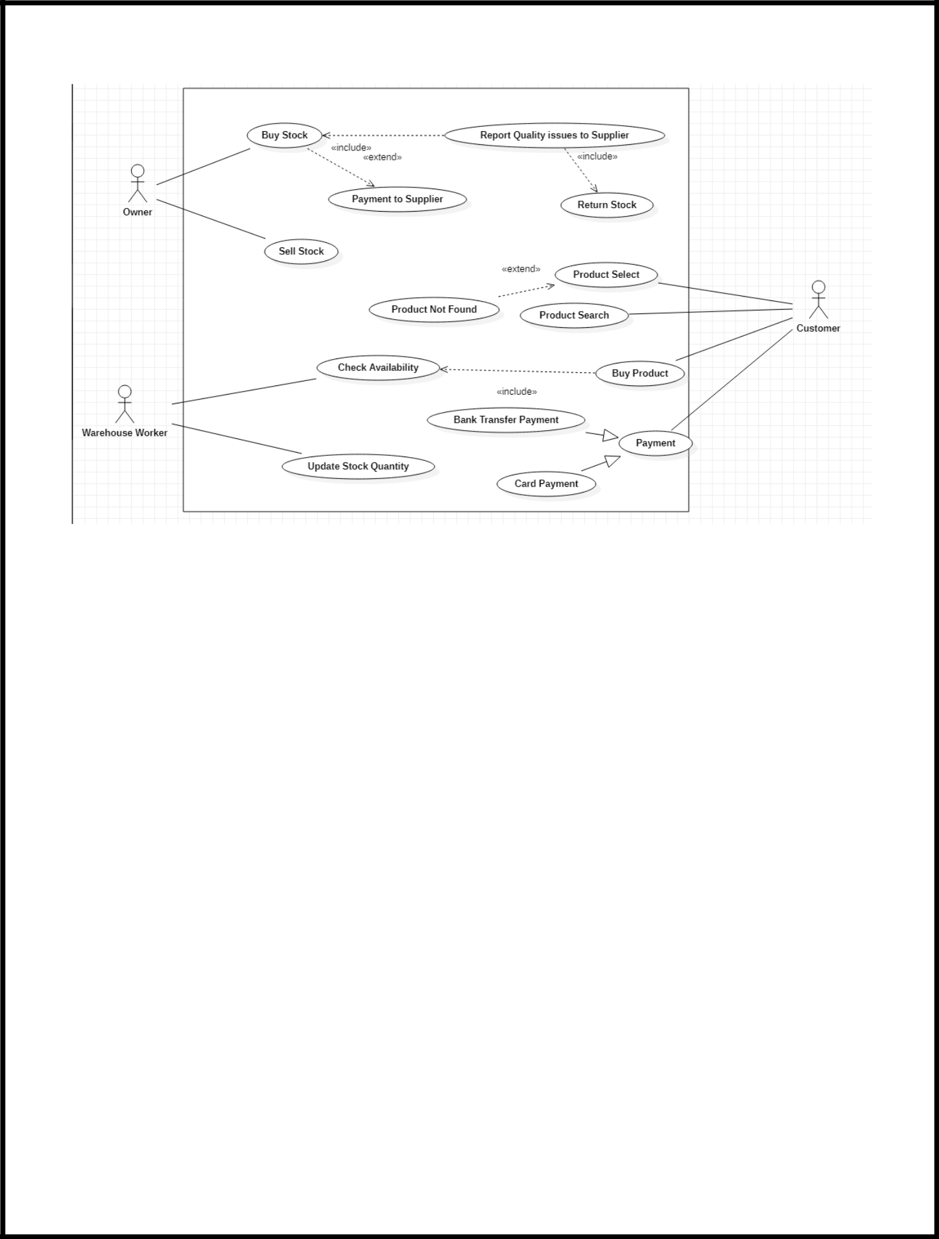

**Sequence Diagram:**

**1.Advance sequence diagram**

The lifeline is the dotted line and the rectangles represent the period of time the object is executing and is hence called activation.

Create message signal is used to indicate the display of failure in any failure situation.

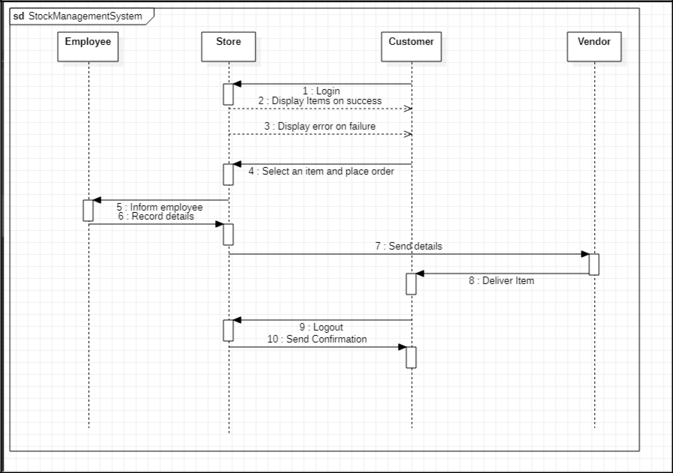

Fig 3.7

19

**Activity Diagram:**

**1. Advance activity diagram**

The advanced activity diagram starts from initiation and then user login activity where a signal is sent to the network for request validation and upon confirmation the control flows to order received and then check inventory activity. There are three swimlanes namely inventory manager, accountant and sale agent where update inventory, update payment and generate bill respectively. Then the control flows to the home page and then termination activities.

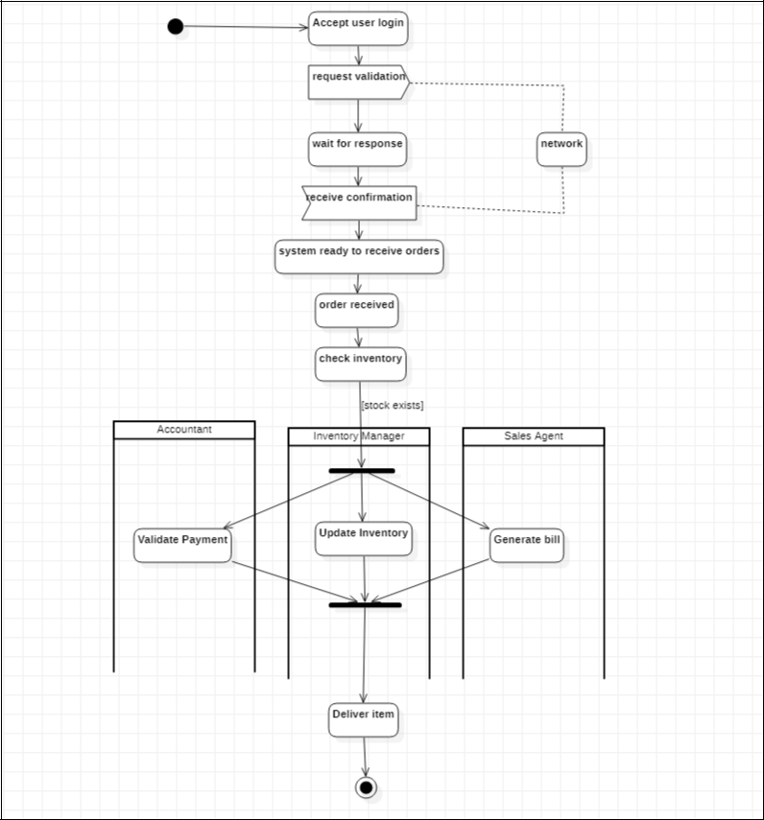

Fig 3.9

20

**4. Coffee Vending Machine**

**Problem statement:**

Design UML diagrams for Coffee Vending Machine with system requirements specification.

**Software Requirements Specification (SRS):**

The Objective of the system is to prepare a coffee vending machine for commercial purposes. The system will be able to prepare coffee by processing all its required ingredients. Users will be provided with sophisticated and easy to use user interfaces.

There are many different types of coffee makers using a number of different brewing principles, in the most common devices, coffee grounds are placed in a paper or metal filter inside a funnel, which is set over a glass or ceramic coffee pot, a cooking pot in the kettle family. Cold water is poured into a separate chamber, which is then heated up to the boiling point, and directed into the funnel.

* Cash Box:Knows amount of money put in; Give change; Knows price of coffee; Turns front panel on and off.
* Front panel:Captures selection; Knows what to mix in each; Instructs mixer when to mix.
* Mixer:Knows how to talk to the dispensers.
* Dispenser [cup-, coffee powder-, sugar-, creamer-, water-]:Knows how to dispense a fixed amount, knows when it is empty.

Features:

* Small carbon footprint
* Energy saving advanced power management system
* Comprehensive drink range
* Simple user interface
* One touch servicing

Working:

Coffee vending machines are quite simple and basic. The way they work is not too different to how a tabletop coffee machine or even a drip coffee machine operates. If you think about it, making coffee is simply adding together coffee beans or grounds to hot water and mixing with milk and sugar, that's exactly what a hot drink vending machine does.

Functions:

* Add heat:to heat the coffee we have 3 options. We could use a heating element where the water gravity fed into a tubular heating element, external to the water reservoir, and boiled out. Secondly, we could use a submersible heating element placed inside of the water reservoir to heat all of the water at once. Thirdly, we could use an external hot plate to heat one or multiple walls of the water reservoir and thus heat the water through surface convection.

21

* Direct Water:The fluids could be directed from the water reservoir to their final destination via tubing, gravity reed, and pump.
* Contain Water/Coffee:To contain the water and coffee we could use one reservoir, two reservoirs or a funnel. If one reservoir was used for both the water and coffee container, our design would be a percolating or French press coffeemaker.
* Reduce Noise:To reduce the overall noise we consider two options: noise dampening material and internal brew mechanism. To lessen the noise produced by our designs we could fill or cover the outer shell of a noise dampening material. We could also keep the brew mechanism, whether it is drip spout.

Maintenance: When it comes to the ways in which coffee vending machines work, it’s not all about the coffee, it’s also about the upkeep and maintenance of the machine. With regular visits, suppliers should empty the cash drawer, reconcile the proceeds against sales, empty the waste grounds, refill ingredients and cups, and generally undertake any work to both the interior and exterior to keep everything running smoothly, such as ensuring there’s no build up of dirt around the exterior buttons that could cause them to stick, and making sure nothing is blocking the internal sensors that could prevent some ingredients from being added to the mixing chamber.

**Class Diagram:**

The below shown class diagram contains the following classes: Coffee Machine, Cash Box, Selector, Dispenser Register, Dispenser, Ingredient, Recipe, Product, Product Register. with multiplicities as shown.

Association: Customer buys Product, Customer buys Stocks, Customer pays Payment.

Generalization: User is generalized to Permission class and User is Generalized to Role.

Aggregation: Coffee Machine contains Cash Box, Selectors, Dispense Register has Dispenser,

Dispenser is composed of Ingredients.

Composition: Recipe is made up of Ingredients

Enumerations: TypeOfCoffee

22

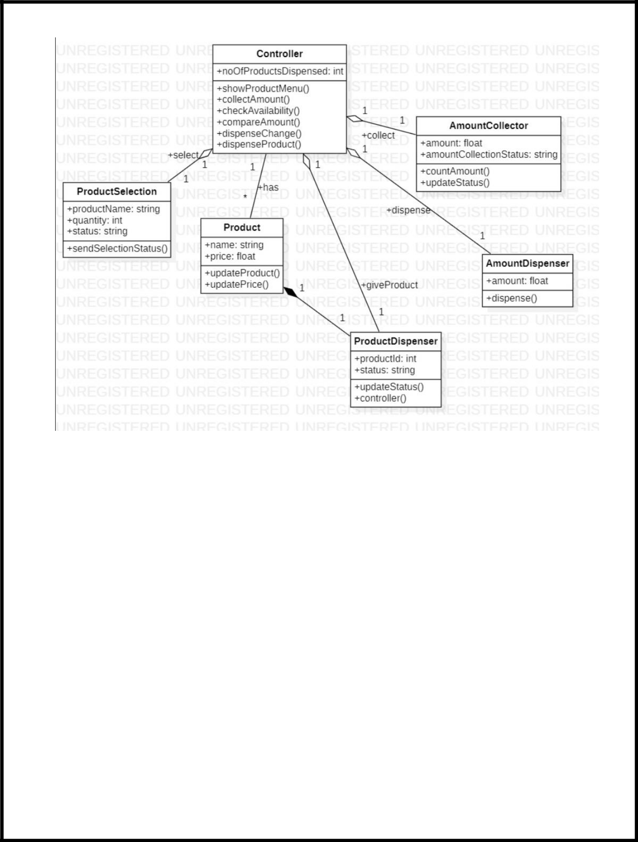

**State Diagram:**

**1. Advance state diagram**

The advanced state diagram depicted below contains one nested state and one submachine, which on successful login shows the CollectingMoney procedure and DispenseItem procedure. It contains initial state and termination state with CollectingMoney as a nested state including the required simple states. It also has a submachine state named DispenseItem with initial, termination state along with simple states; SettingRow, SettingColumn, Pouring.

23

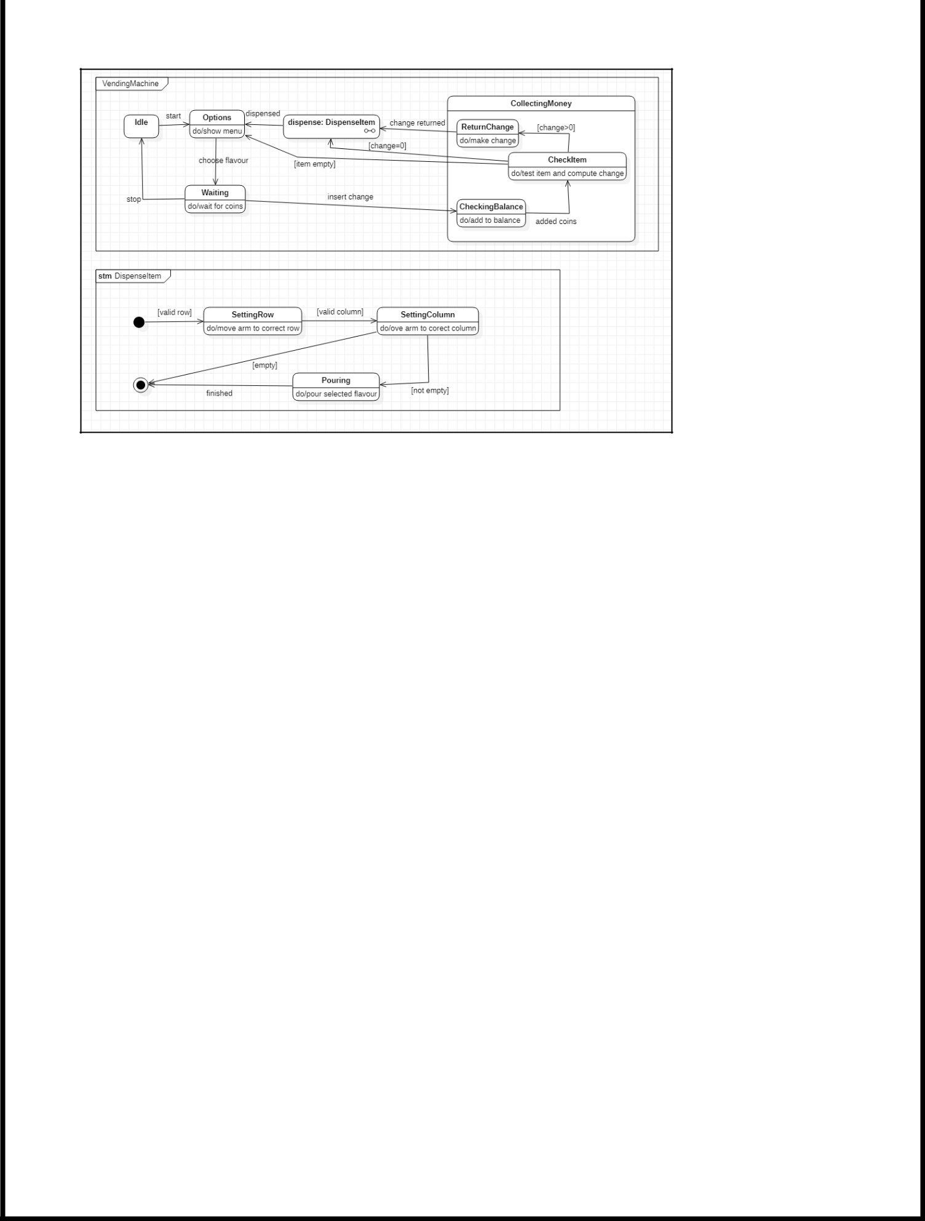

24

**Use Case Diagram:**

**1. Advance use case diagram**

The advanced use case diagram has extra functionalities which includes extends, includes and generalization. The dispense change use case extends payment use case, payment use case extends buy item use case, buy item use case includes choose item and take item use case. Capucchino dispense and American dispense is generalized to super class dispense coffee.

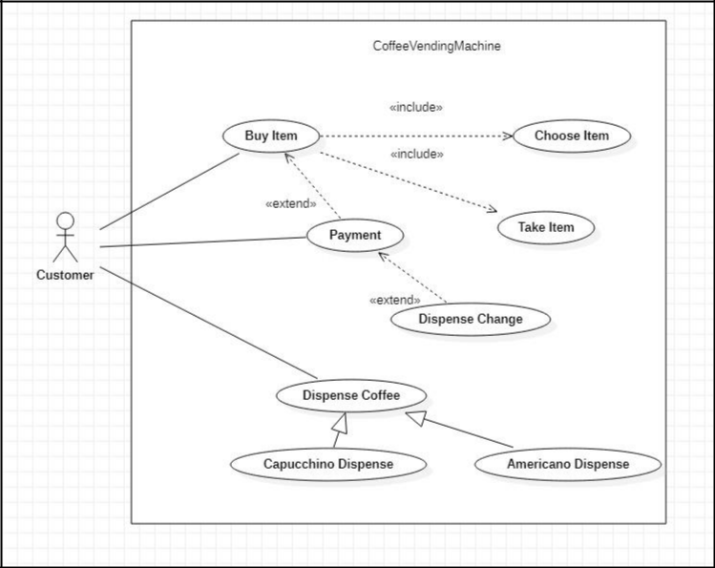

25

**Sequence Diagram:**

**1. Advance sequence diagram**

The lifeline is the dotted line and the rectangles represent the period of time the object is executing and is hence called activation.

The recursive function of customise is shown by double activation rectangle of customise and verify coins.

The passive object Printer is created when the customer asks for printing and is destroyed (turned off) after sending the receipt.

A time constraint of 1 to 10 seconds is given for depositing coins by the customer in the vending machine.

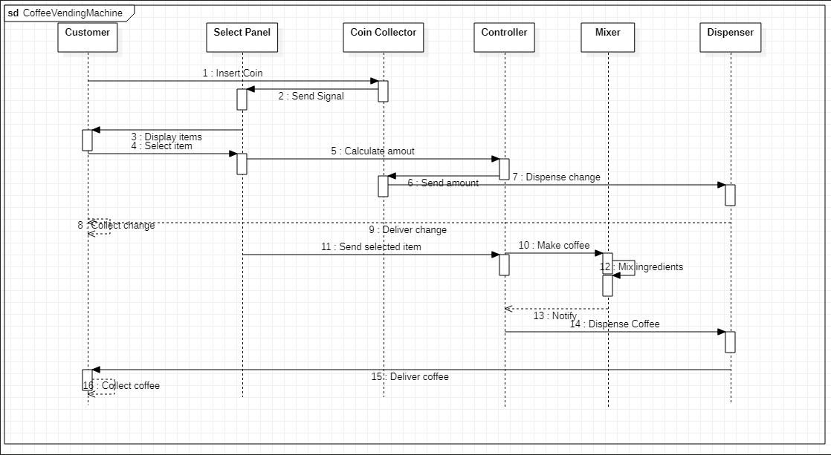

26

**Activity Diagram:**

**1. Advance activity diagram**

The advanced activity diagram starts from initiation and in the customer swimlane, customer login activity where a signal is sent to the network for request validation and upon confirmation the control flows to order received and then check inventory activity. There are three swimlanes namely customer, coffee dispenser and payment where customer perform operations like order coffee, dispenses coffee and collect coins respectively. Then the control flows to the home page and then termination activities.

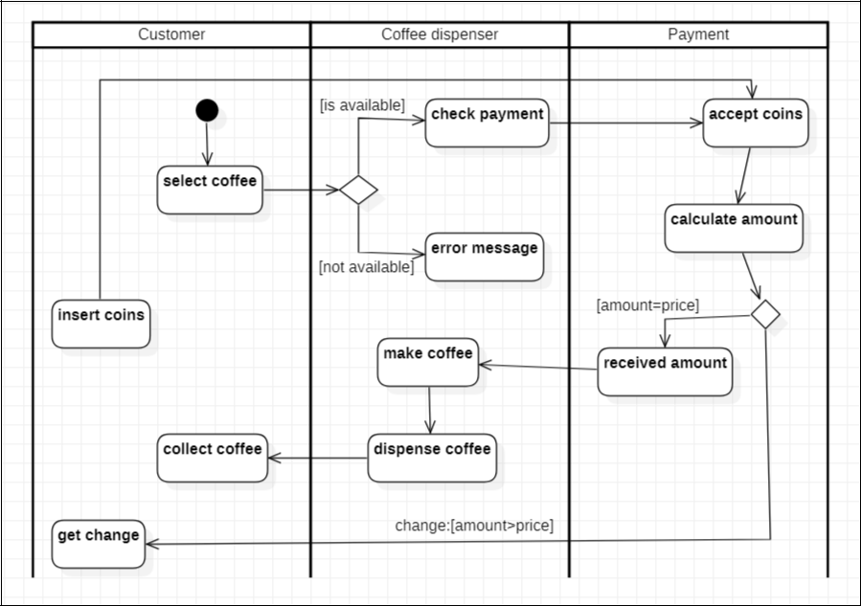

Fig 4.9

27

**5. Online Shopping System**

**Problem statement:**

Design UML diagrams for Online Shopping System with system requirements specification.

**Software Requirements Specification (SRS):**

The online shopping system allows the users and vendors to exchange products remotely and reduces the amount of cost and time substantially. The software provides the following facilities to the customers:

* Facilitates easy shopping online anywhere with free shipping (conditions apply).
* Provides information about the products in categories
* Can avail the facility of purchasing second hand products
* Can reserve if the particular product is not available
* Customers are provided with up to date information on the products available
* Provides email facility for future correspondence
* Provides backup facility
* Can add nearly ten products to their shopping cart at a time
* Cannot reserve the product for more than two days.
* Cannot reserve more than two products
* Responsibility of damages
* The product cannot be changeable once confirmed
* Facilitates easy bidding facility
* Provides complete information about the customers
* Provides complete information about their products

28

* Can avail the facility of email correspondence and avail the brand catalog facility

**Class Diagram:**

The below shown class diagram contains the following classes: WebUser, Customer, ShoppingCart, Account, Product, Order, Payment, Netbanking, COD with multiplicities as shown. Association: WebUser owns ShoppingCart, ShoppingCart has Product, Order consists of Product, Payment completes Order.

Generalization: Netbanking and COD are generalized to Payment class.

Association class: LineItem with ShoppingCart and Product

Composition: Account is composed of ShoppingCart, Customer, and Order.

Enumerations: UserState, OrderStatus

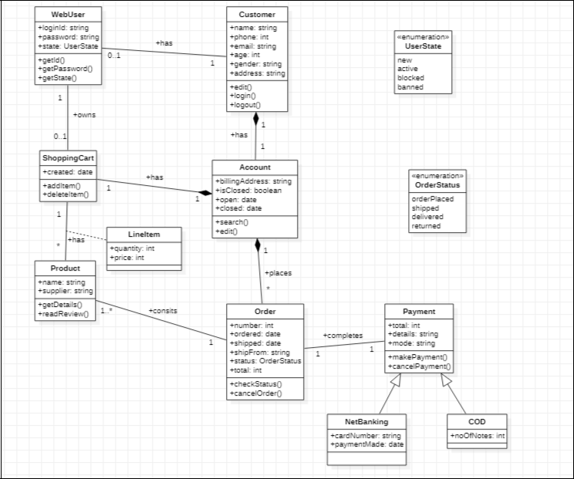

29

**State Diagram:**

**1. Advance state diagram**

The advanced state diagram depicted below contains one nested state and one submachine, which on successful login shows the AddToCart procedure and PaymentSystem procedure. It contains initial state and termination state with AddToCart as a nested state including the required simple states. It also has a submachine state named PaymentSystem with initial, termination state along with simple states; Method, Card, Validation, Processing.

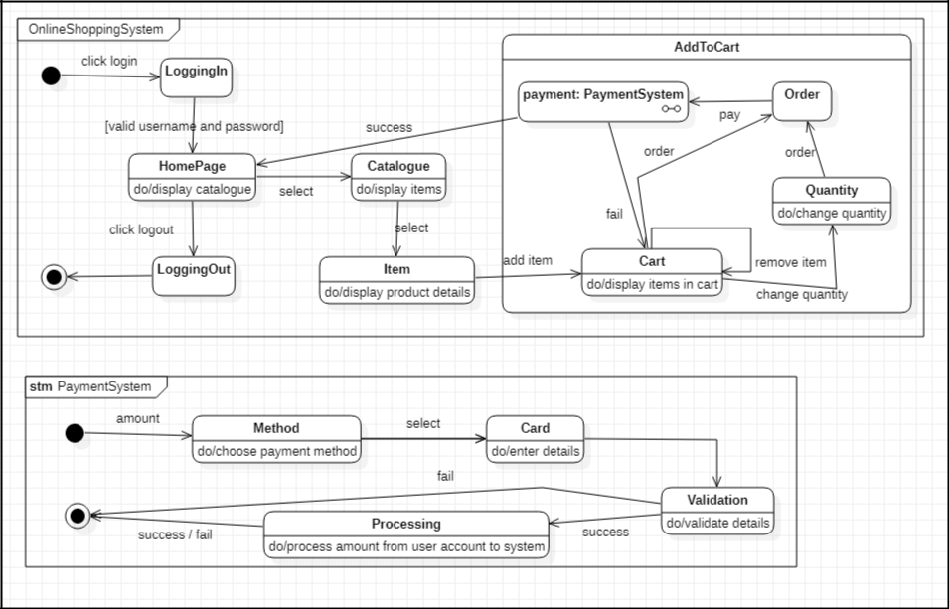

**Use Case Diagram:**

**1. Advance use case diagram**

The advanced use case diagram has extra functionalities which includes extends, includes and generalization. The delete from cart use case extends add item to cart use case, place order use case includes make payment use case, check authentication use case includes make finalized payment and add tax use case. Add item, remove item and update quantity is generalized to super class maintain stock.

30

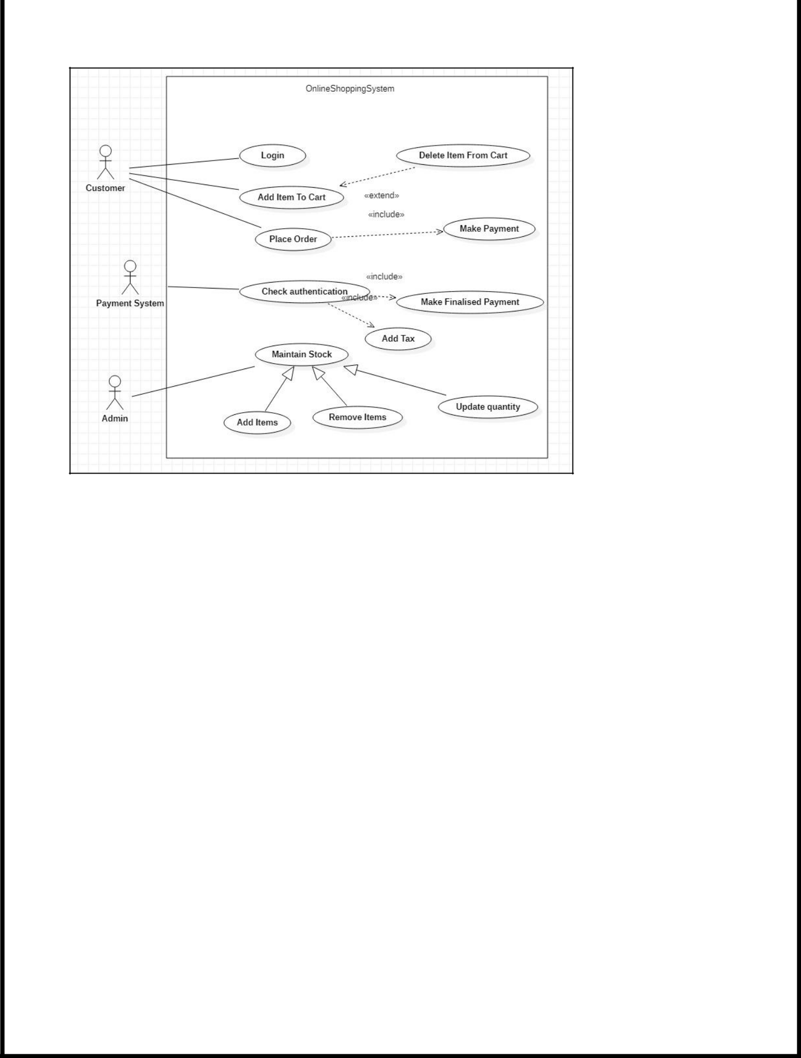

**Sequence Diagram:**

**1. Advance sequence diagram**

The lifeline is the dotted line and the rectangles represent the period of time the object is executing and is hence called activation.

Reply message is used to to return back to lifelines with the required message.

31

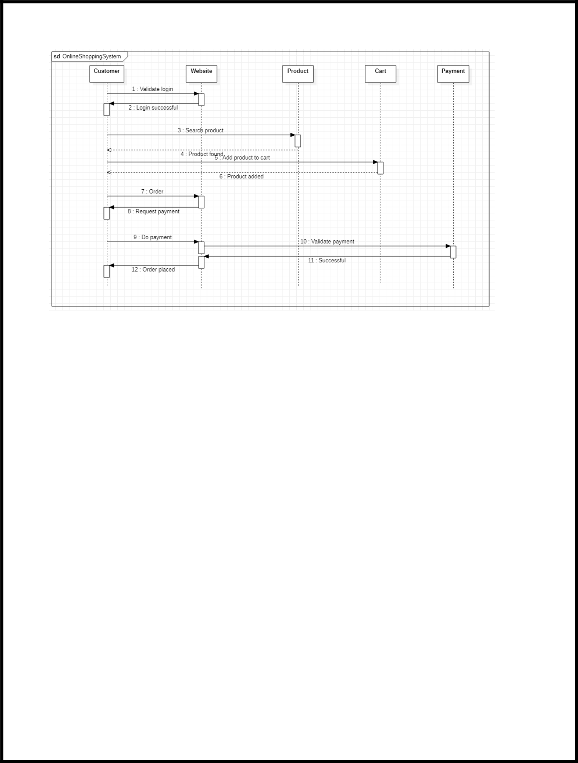

**Activity Diagram:**

**1. Advance activity diagram**

The advanced activity diagram starts from initiation and in the customer swimlane, the customer login activity where a signal is sent to the network for request validation and upon confirmation the control flows to add product and checkout activity. There are two swimlanes namely customer and online shop where it confirms the order and delivery, payment process respectively. Then the control flows to the home page and then termination activities

32

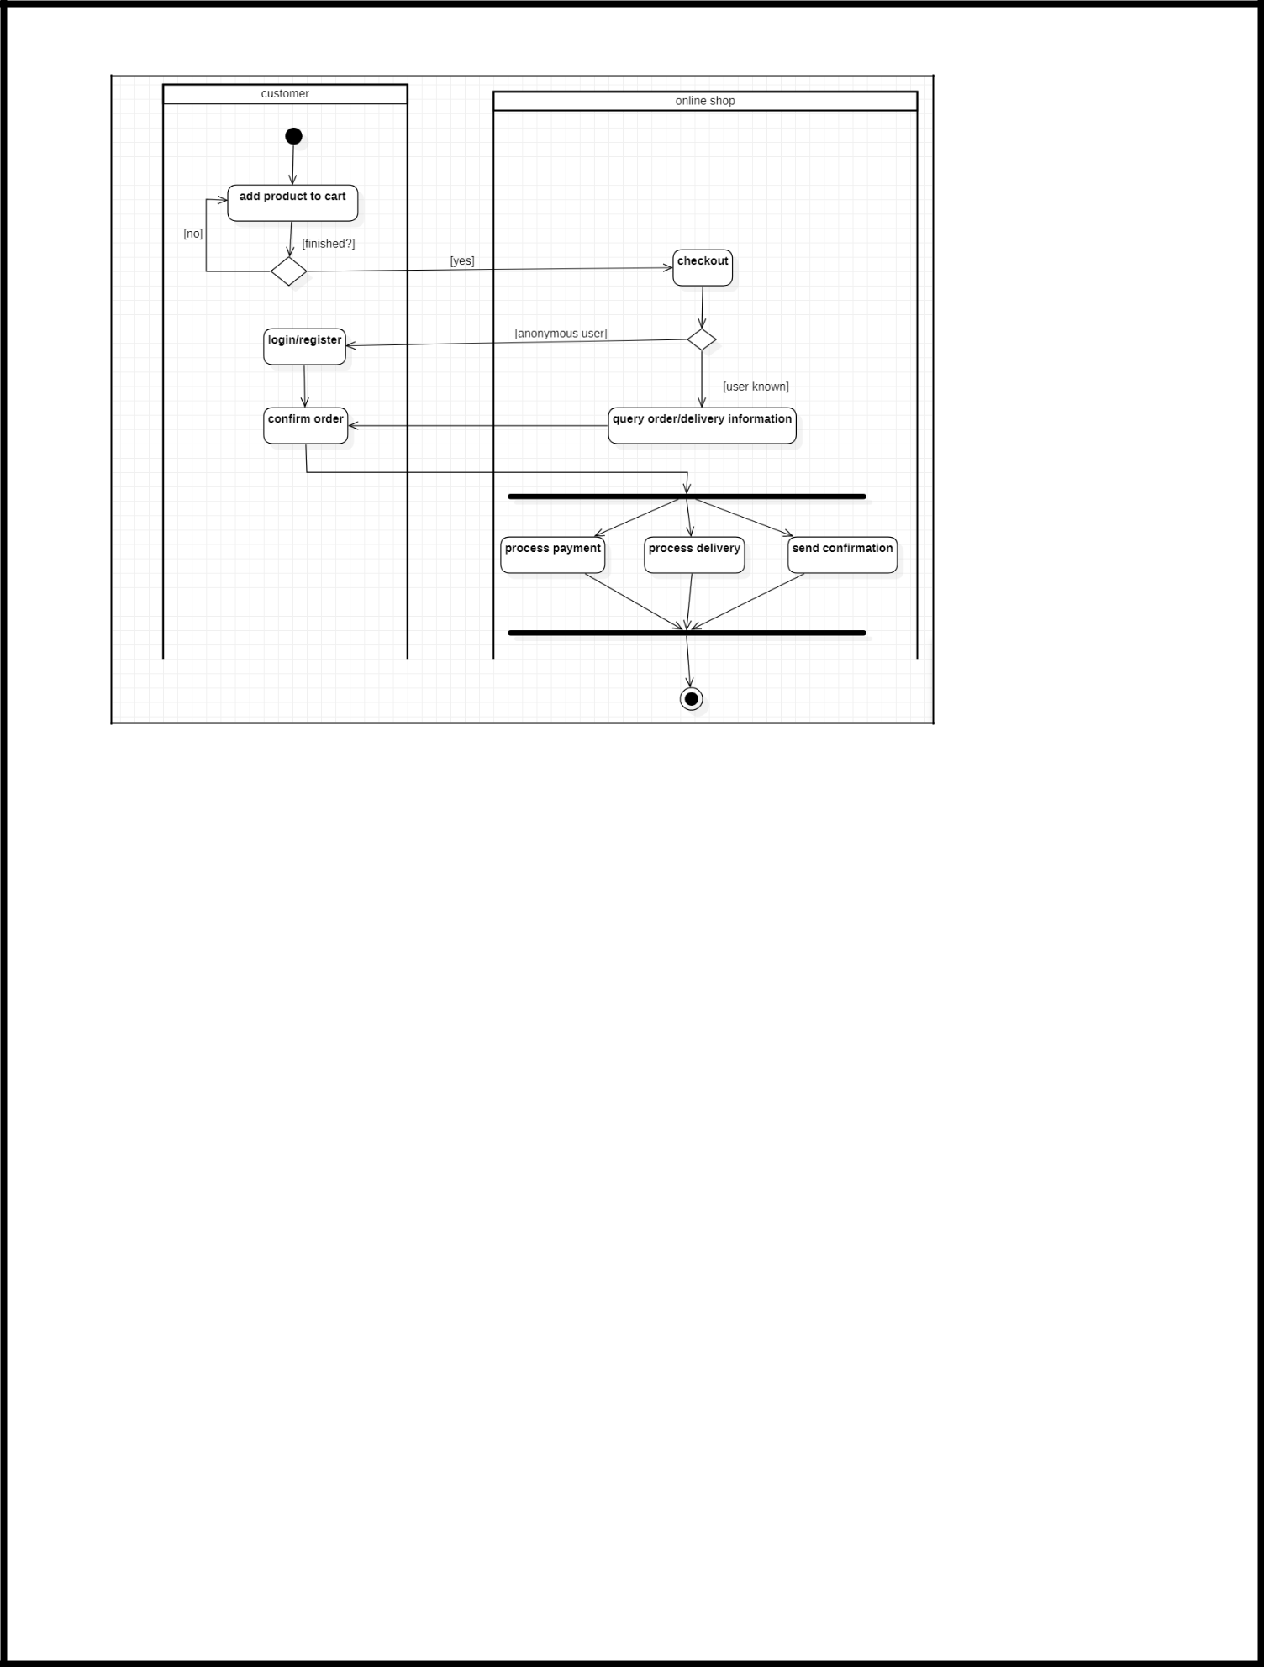

33

**6. Railway reservation system**

**Problem statement:**

Design UML diagrams for Railway Reservation System with system requirements specification.

**Software Requirements Specification (SRS):**

To develop a user-friendly Railway Reservation System to enable passengers to book tickets online

and make payment online as well. Railway reservation system project which provides the train

timing details, reservation, billing and cancellation on various types of reservation namely,

* Confirm Reservation for Seat.
* Reservation against Cancellation.
* Waiting list Reservation.
* Online Reservation.
* Tatkal Reservation

This system enables the Advance booking in any class, against general and ladies quota, on

payment of fare in full for adults and children, a maximum of six berths/seats at a time, for journey

between any two stations served by a train. It also provides details about

1. Timetable
2. Train Fares
3. Current status of reservation position
4. Train available between a pair of stations
5. Accommodation available for a train/date combination Types of tickets: General and Tatkaal

**Class Diagram:**

The below shown class diagram contains the following classes: RailwayStation, Train, Admin, Passenger, TicketBooking, Payment, Ticket, General and Tatkal with multiplicities as shown. Association: Passengers takes Train, Admin supervises TicketBokking, TicketBooking pays Payment.

Generalization: General and Tatkal are generalized to Tickett class.

Association class: Bank with TicketBooking and Payment

34

Composition: RailwayStation contains train, Passenger books TicketBooking, TicketBooking has Ticket.

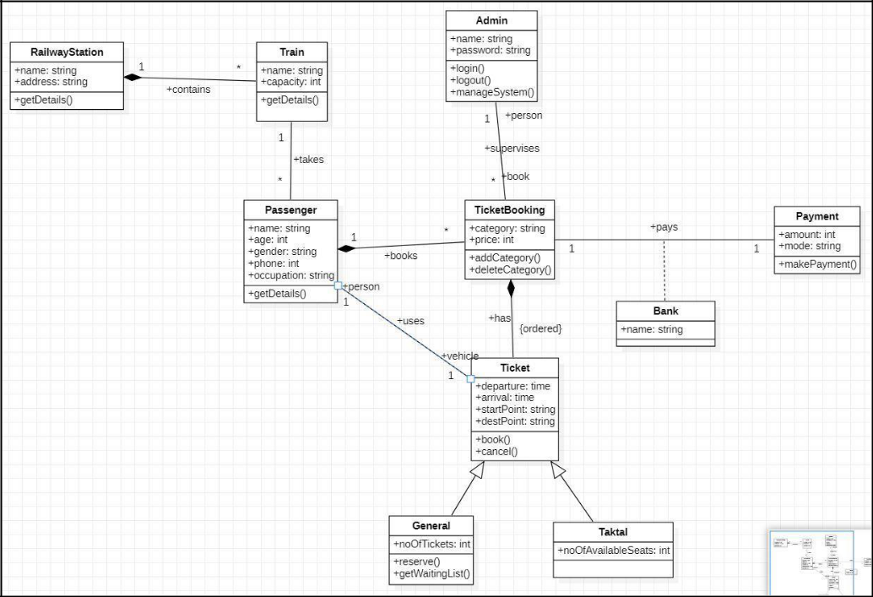

**State Diagram:**

**1. Advance state diagram**

The advanced state diagram depicted below contains one nested state and one submachine, which on successful login shows the ChooseTrain details and PaymentSystem procedure. It contains initial state and termination state with ChooseTrain as a nested state including the required simple states. It also has a submachine state named PaymentSystem with initial, termination state along with simple states; Method, Card, Validation, Processing.

35

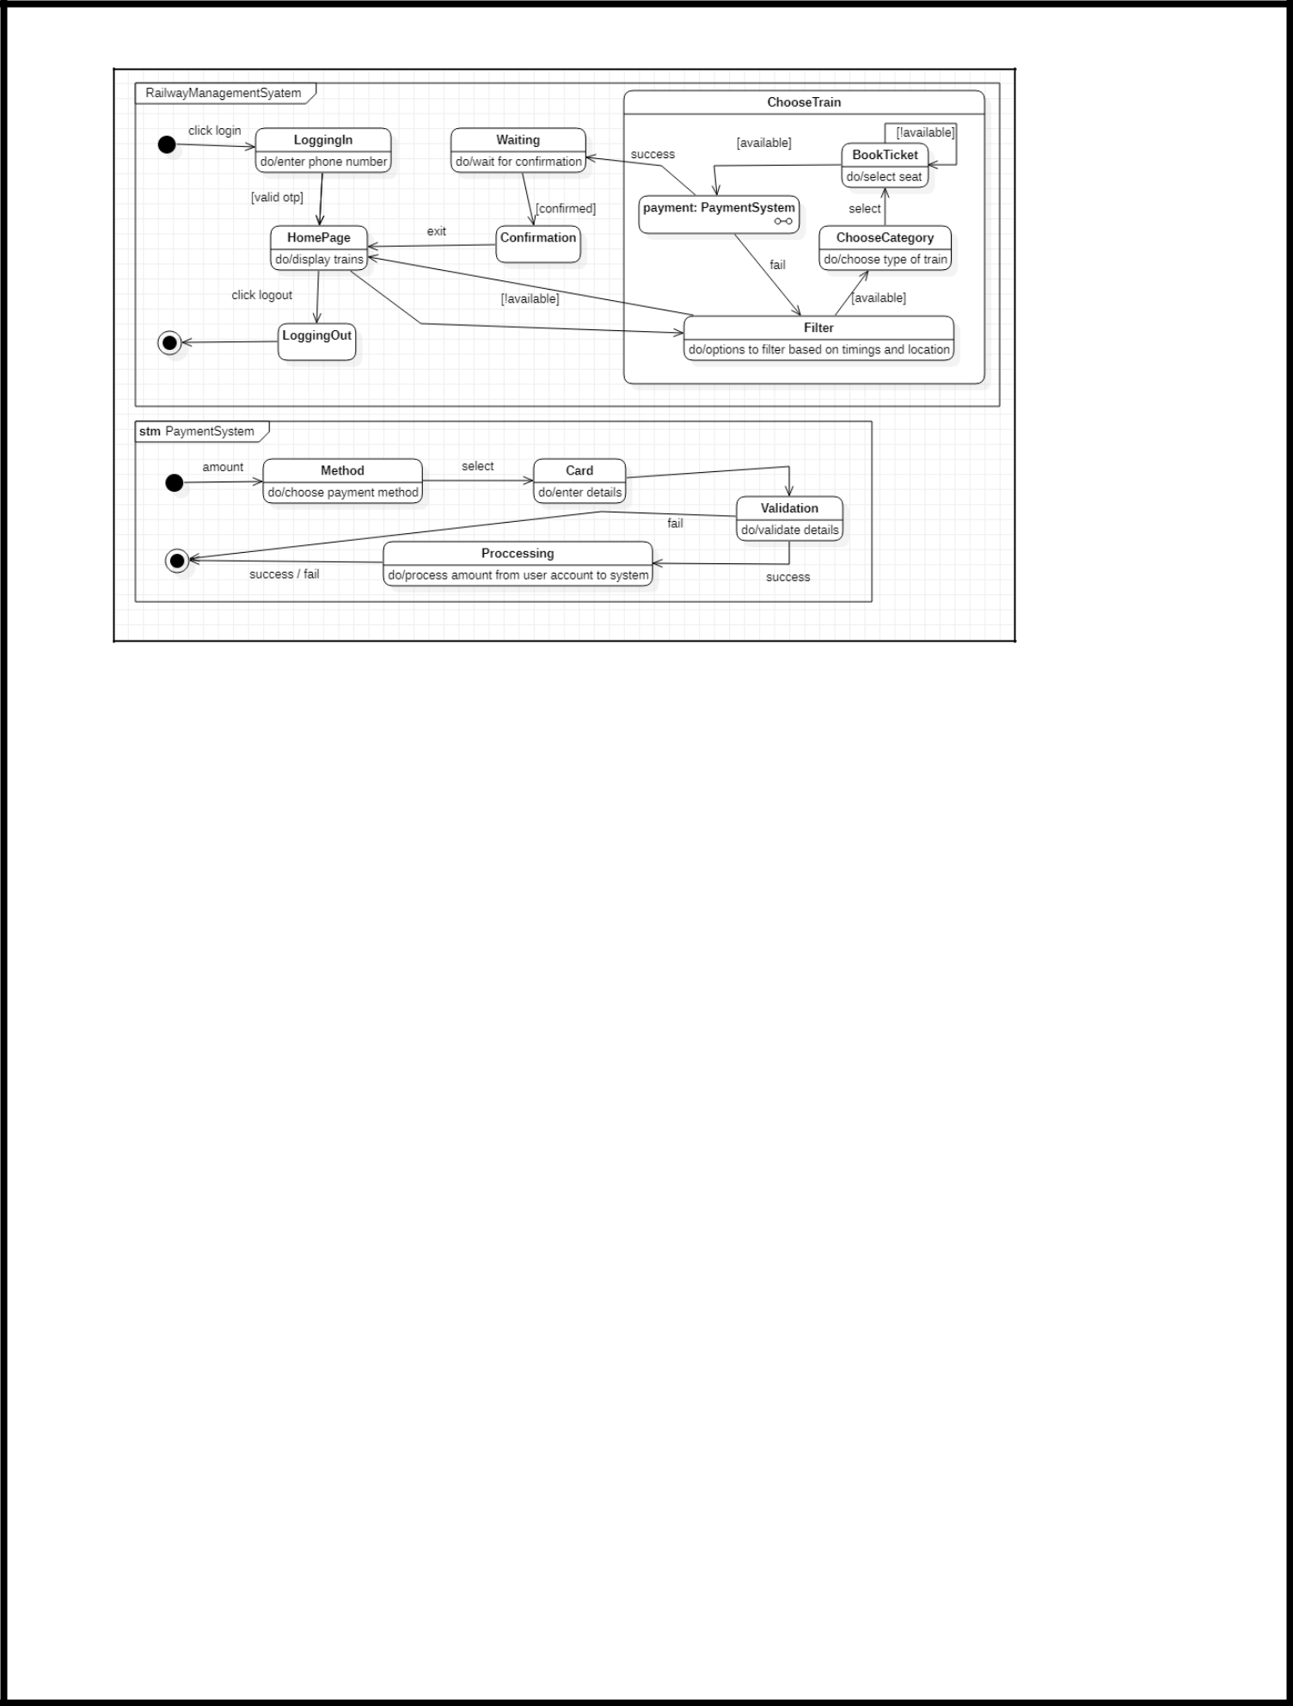

**Use Case Diagram:**

**1. Advance use case diagram**

The advanced use case diagram has extra functionalities which includes extends, includes and generalization. The cancel ticket use case extends refund money use case, check availability use case extends book ticket use case, book ticket use case includes fill details use case, fill details use case includes make payment. Online and offline is generalized to super class make payment.

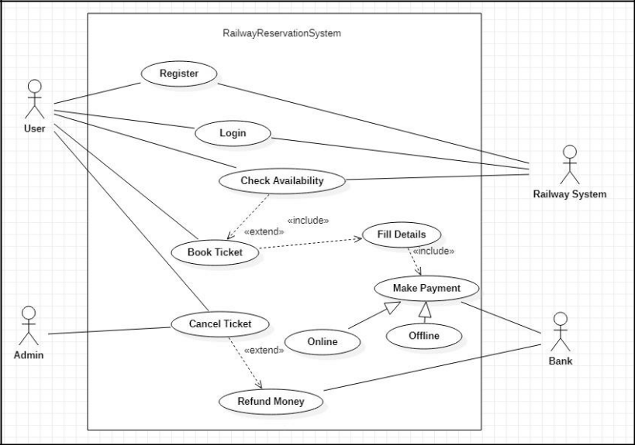

Fig 6.5

36

**Sequence Diagram:**

**1. Advance sequence diagram**

The lifeline is the dotted line and the rectangles represent the period of time the object is executing and is hence called activation.

The recursive function of validation is shown by double activation rectangle of validation with self-transition and verify user.Reply message is used to to return back to lifelines with the required message.

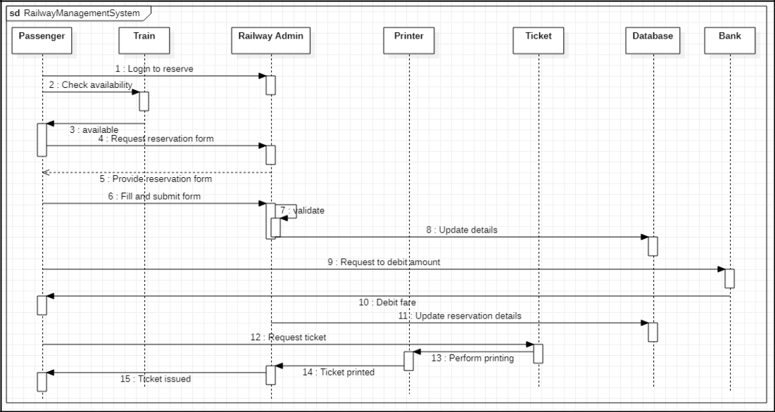

**Activity Diagram:**

**1. Advance activity diagram**

The advanced activity diagram starts from initiation and in the passenger swimlane, the passenger

login activity where a signal is sent to the network for request validation and upon confirmation

the control flows to check seat availability activity. There are four swimlanes namely passenger,

railway database, railway authority and bank where each one indicates the passenger operations,

check seat availability, check validation, confirm payment respectively. Then the control flows to

the home page and then termination activities.

37

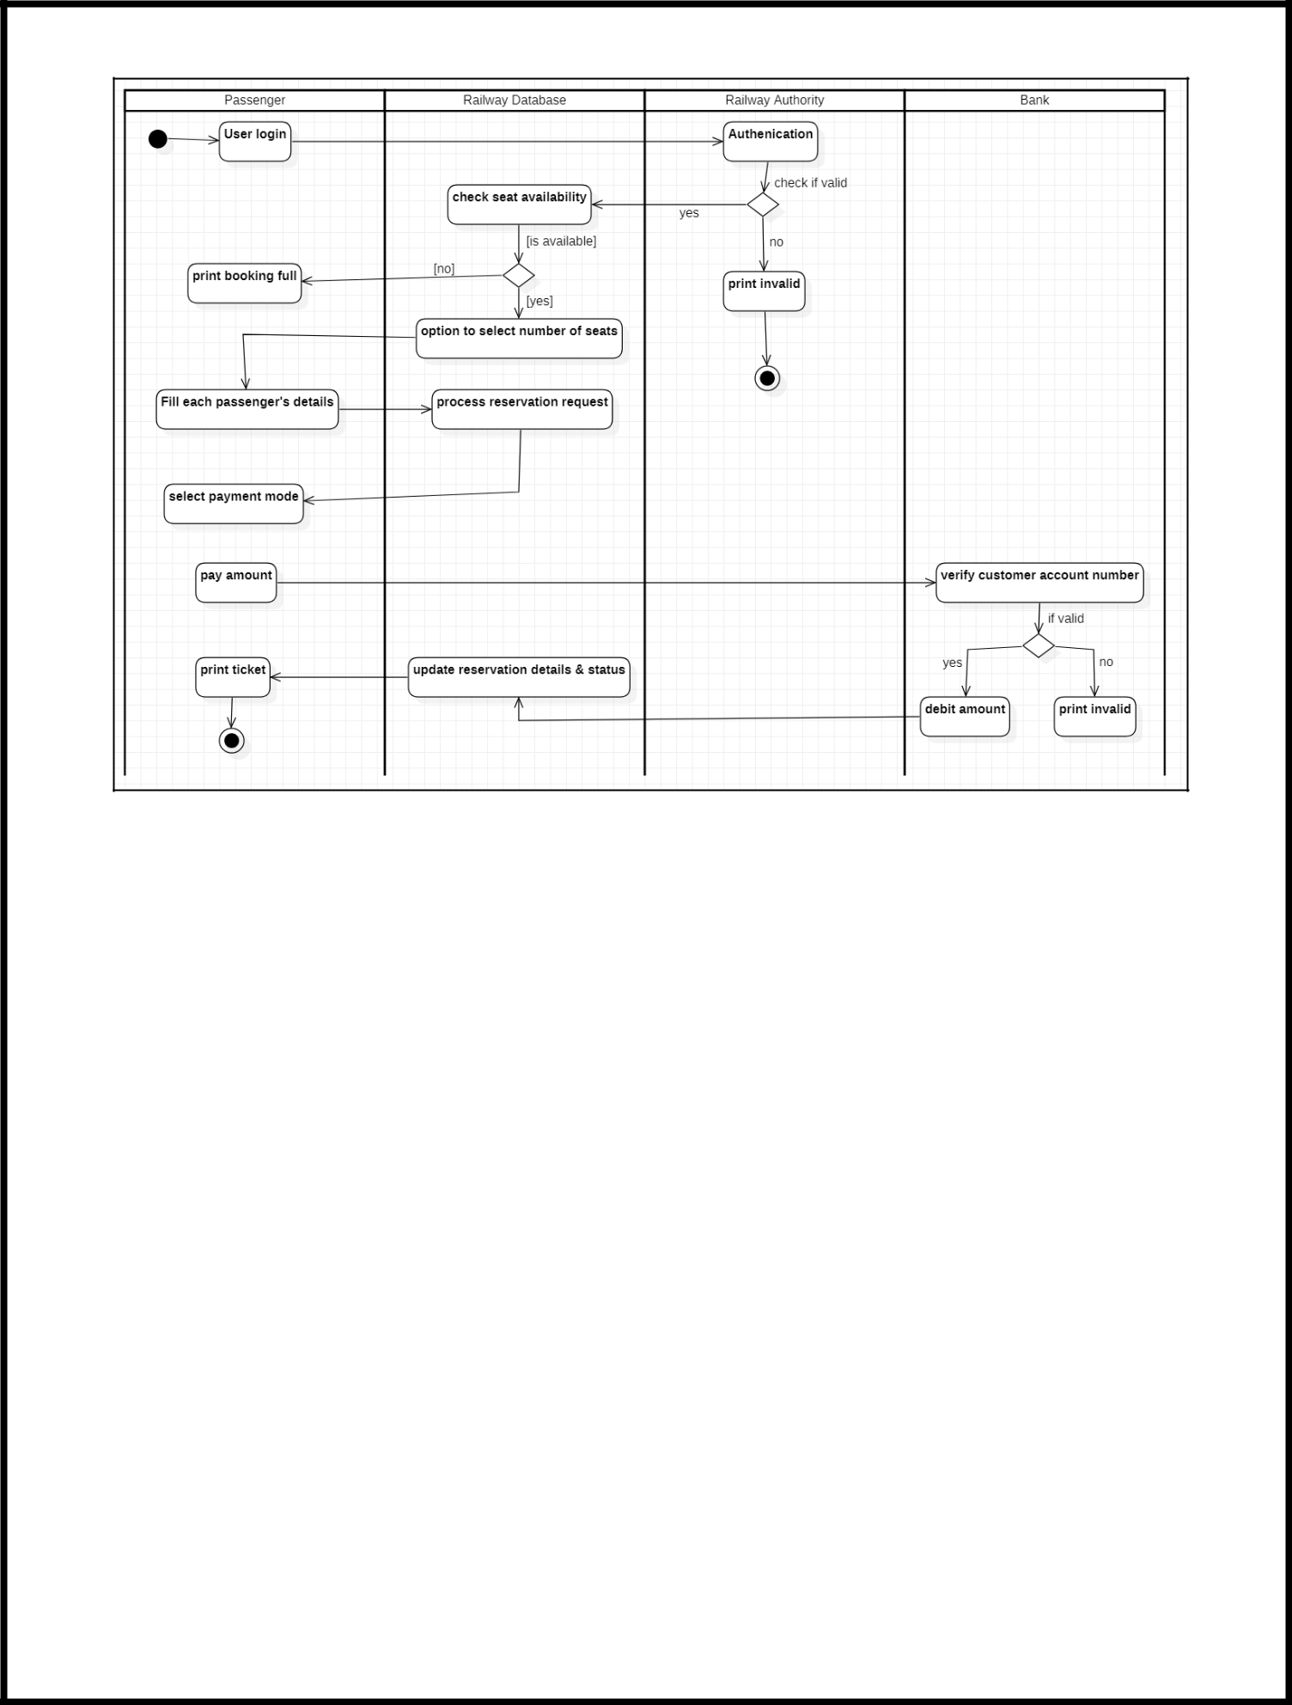

38

**7. Graphics Editor**

**Problem statement:**

Design UML diagrams for Graphics Editor with system requirements specification.

**Software Requirements Specification (SRS):**

The graphics editor provides an Application Programmer’s Interface that enables a programmer to develop their own graphical model editor for a specific type of model. This API in turn, relies on extending the Eclipse Graphical Editing Framework to provide an environment in which the editor functions, and the programmer can create a graphical editor and palette of shapes in order to modify an underlying model. The graphical editor provides an interface with which the programmer implements said editor for a given underlying model. Such an instance of the graphical editor allows a user to drag objects from a specified model into a working graphical diagram.

It should support following functionalities:

* It contains the toolbox which contains tools like: Line, Circle, Rectangle, Arc,Text, Draw, Eraser
* Color box or palette
* Standard toolbar with options for New, Open, Save, toolbox and Text Toolbox.
* One integrated view to users for toolbar, color box, menu, and graphic screen.
* Easy handling of tools for users.
* Ability to group several drawings into one i.e., complex drawing.
* Provision of zoom in and zoom out.
* Different shadings of line tool are provided

39

**Class Diagram:**

The below shown class diagram contains the following classes: GraphicEditor, Document, Sheet, Group, Object, Text, ZeroDimension, OneDimension, TwoDimension, Point, Line, Arc, Circle, Rectangle, Ellipse with multiplicities as shown.

Generalization: Text, ZeroDimension, OneDimension, and TwoDimension are generalized to Object class. Point is generalized to ZeroDimension, Line and Arc are generalized to OneDimension, Circle, Rectangle and Ellipse are generalized to TwoDimension.

Composition: GraphicsEditor madeof Document, Document containsOf Sheet, Sheet has Group,

Group has Object.

Enumeration: Point

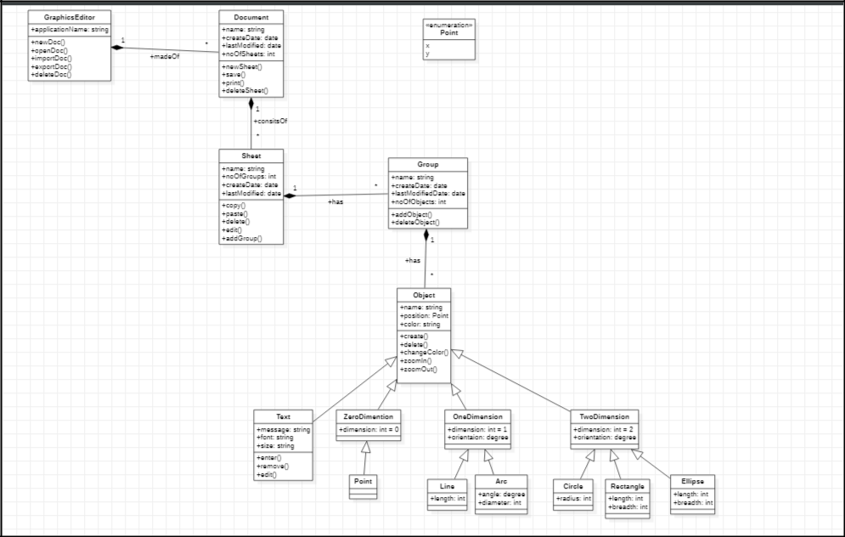

**State Diagram:**

**1. Advance state diagram**

The advanced state diagram depicted below contains one nested state and one submachine, which

on successful login shows the Saving procedure and DrawingSystem procedure. It contains initial

state and termination state with Saving as a nested state including the required simple states. It also

has a submachine state named DrawingSystem with initial, termination state along with simple

states; Shapes, Display and format each shape.

40

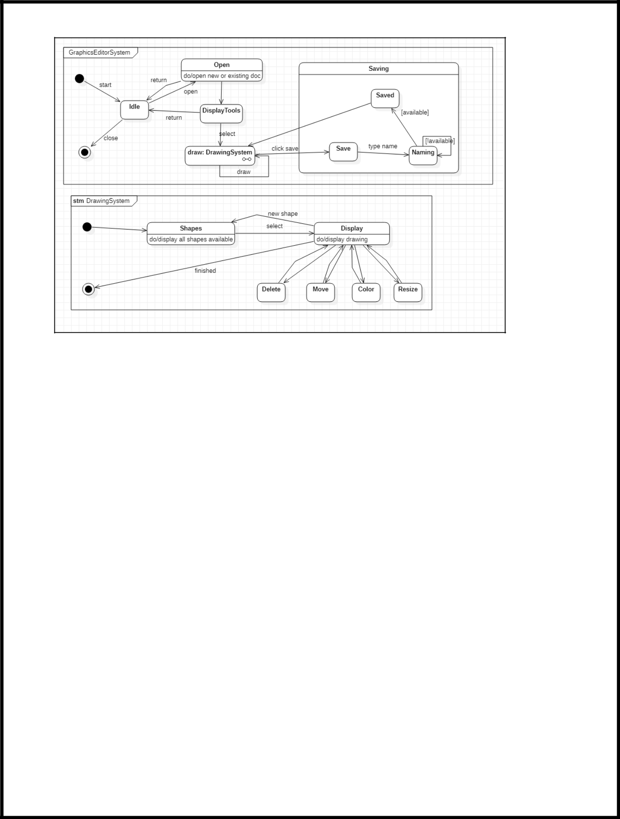

Fig 7.3

**Use Case Diagram:**

**1. Advance use case diagram**

The advanced use case diagram has extra functionalities which includes extends, includes and generalization. The edit document use case extends new document use case, delete document use case extends new document use case, graphic tools use case extends new document use case, new document use case includes save document use case. Insert, delete and color is generalized to super class graphics tools.

41

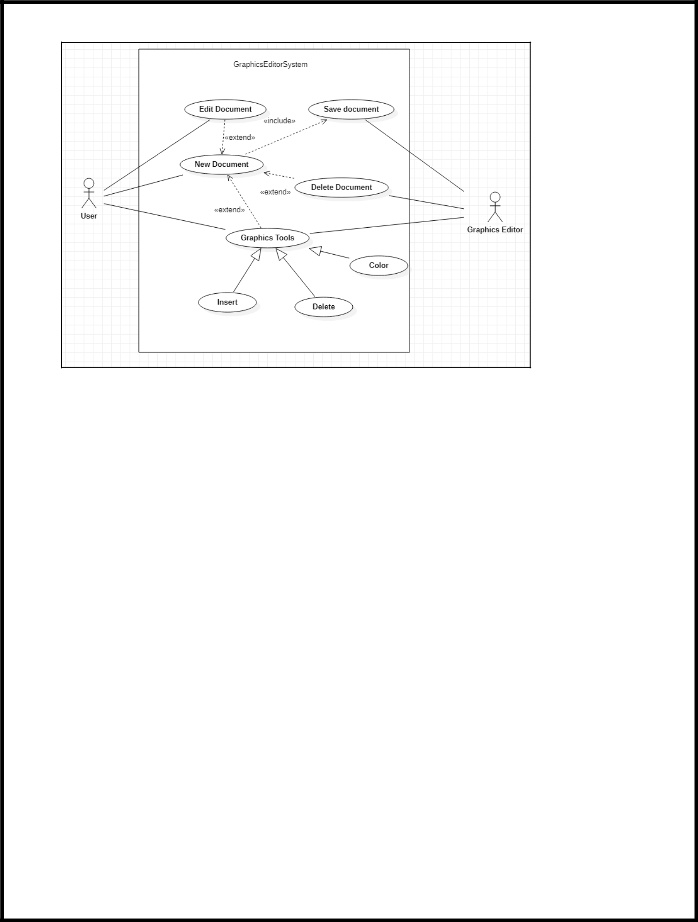

**Sequence Diagram:**

**1. Advance sequence diagram**

The lifeline is the dotted line and the rectangles represent the period of time the object is executing and is hence called activation.

Reply message is used to to return back to lifelines with the required message.

42

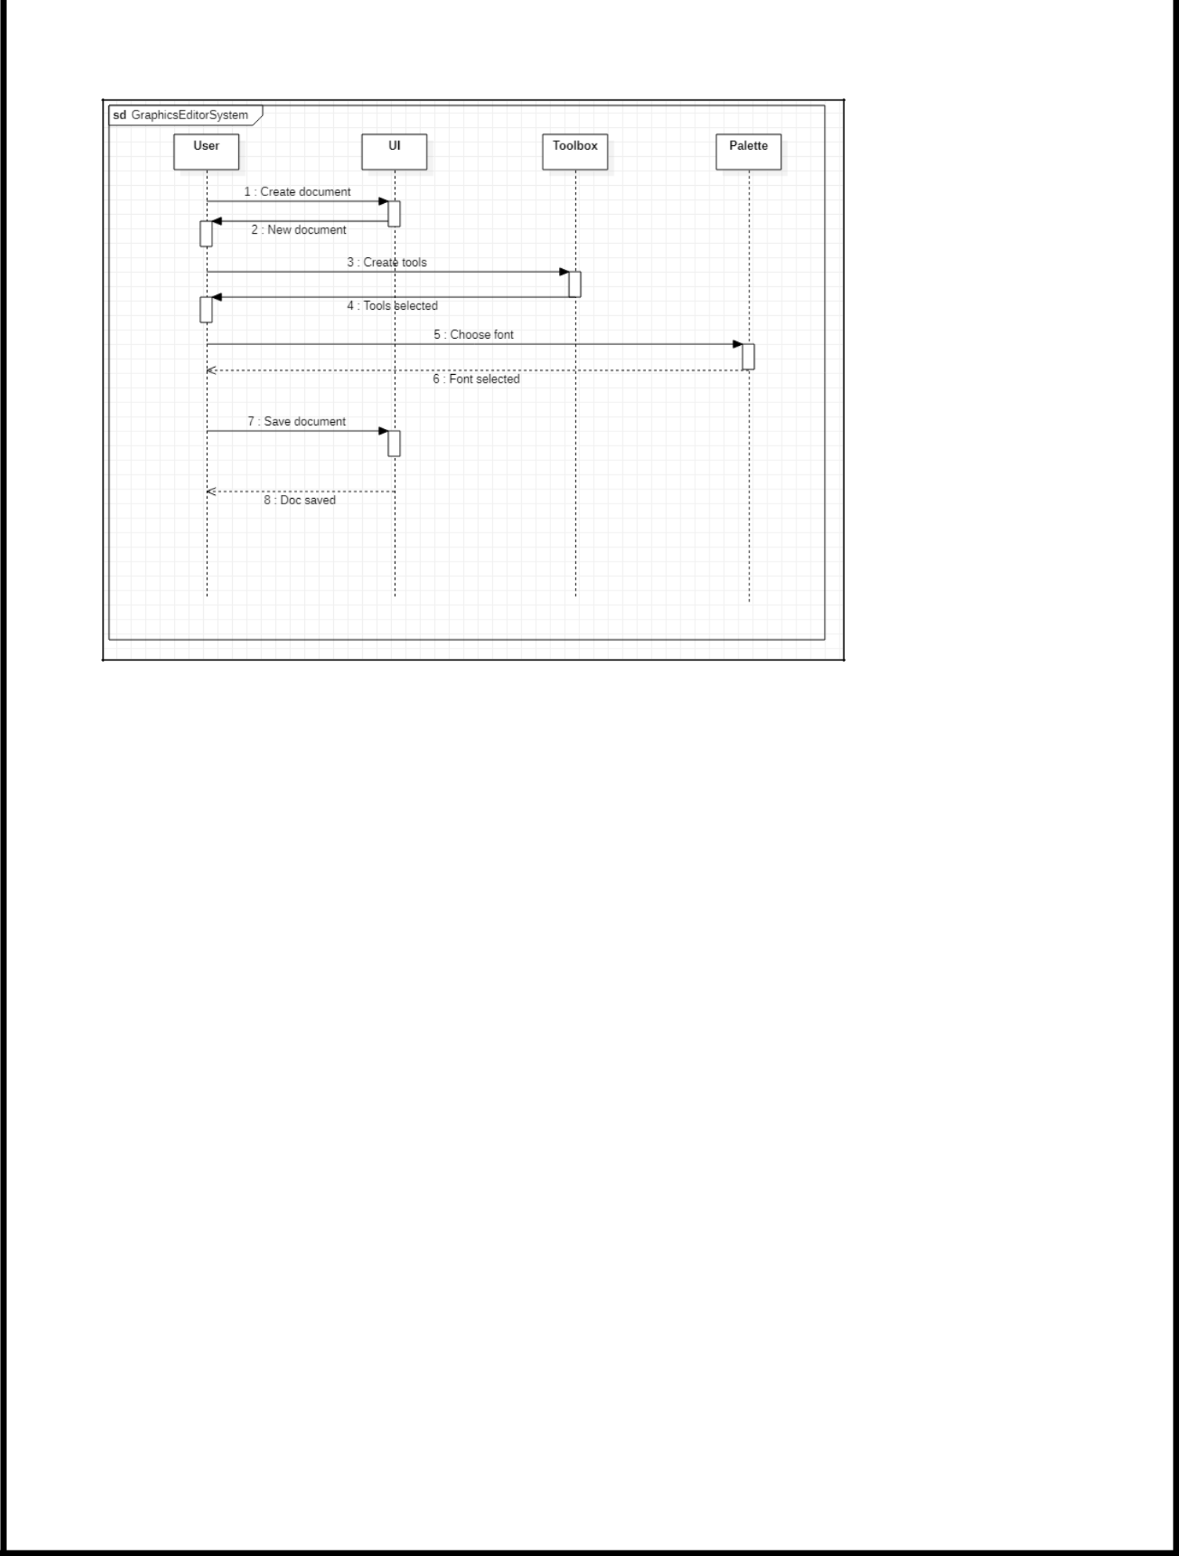

**Activity Diagram:**

**1. Advance activity diagram**

The advanced activity diagram starts from initiation and in the user swimlane, the user login activity where a signal is sent to the network for request validation and upon confirmation the control flows to open file activity. There are two horizontal swimlanes namely user and editor where each one indicates the user operations and drawing a diagram respectively. Then the control flows to the close file activity and then termination activities.

43

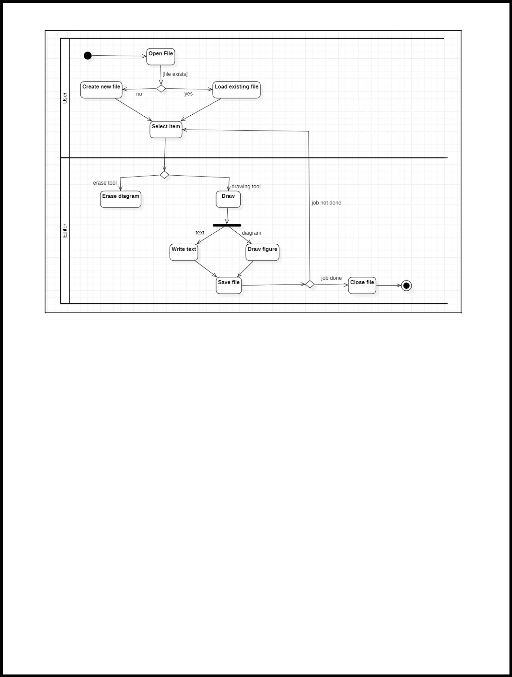

44